VPC

1. Go to vpc and create a vpc …

Ip : 10.0.0.0/16

1. Go to subnet and create two subnets within the vpc created above

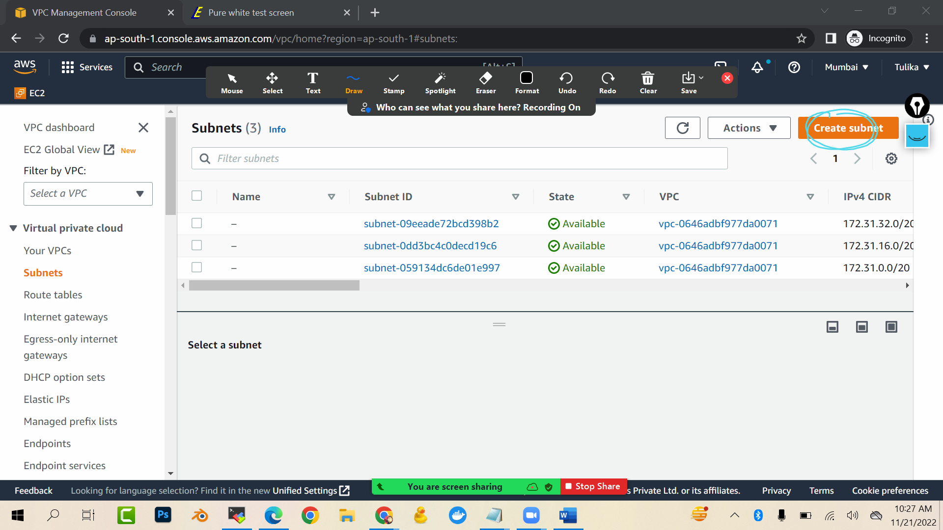

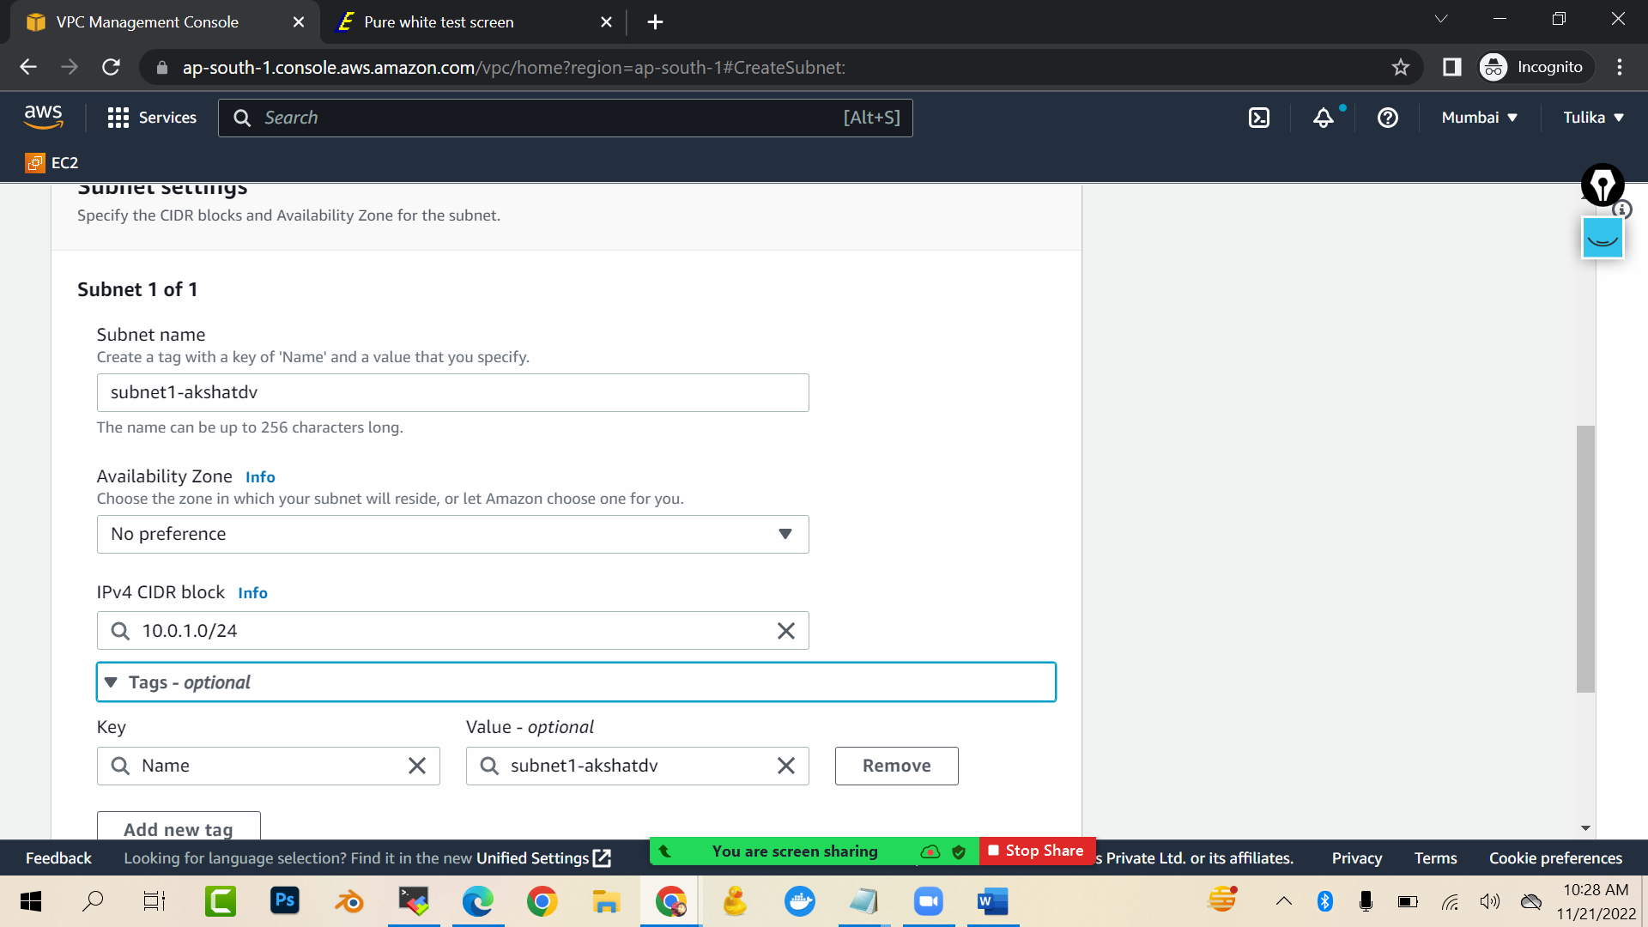

Create subnet

Create one more subnet2 with ipv4 as 10.0.2.0/24

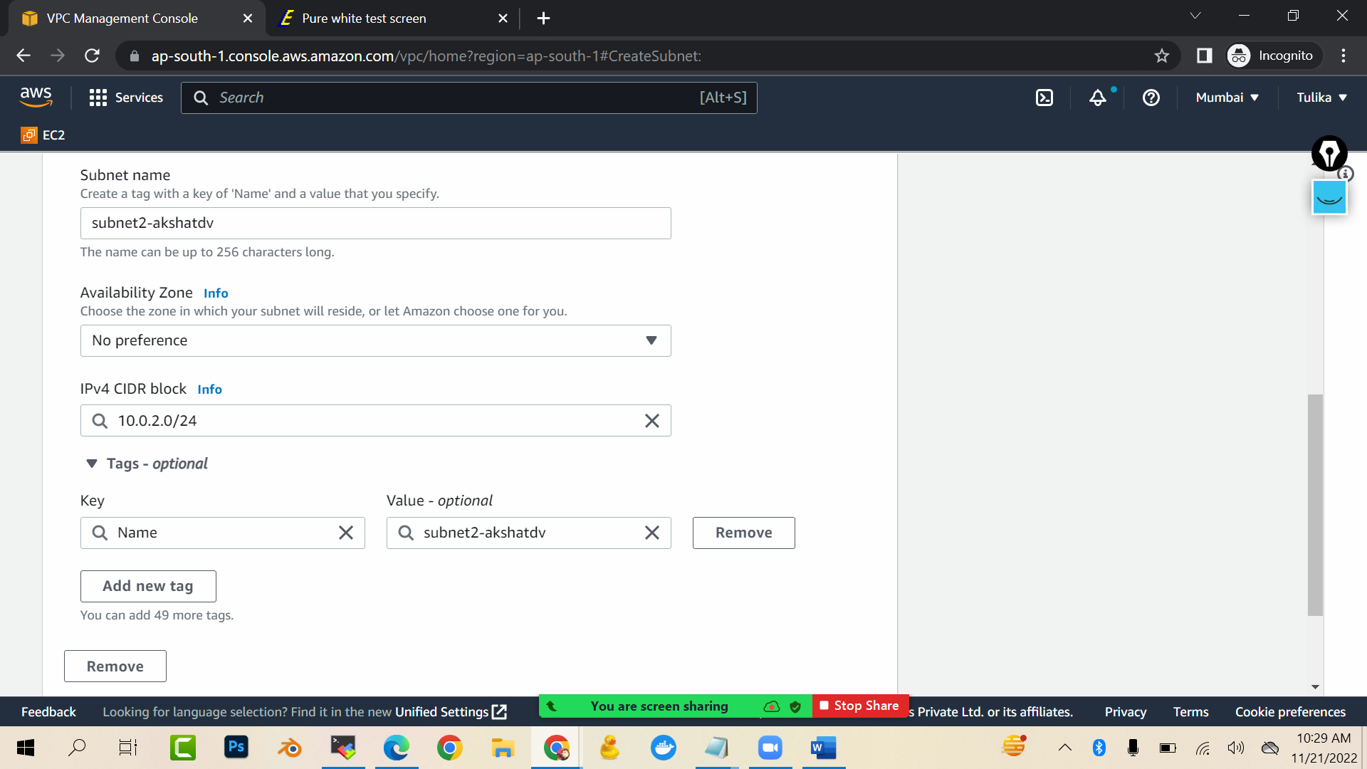

1. Now create internet gateway

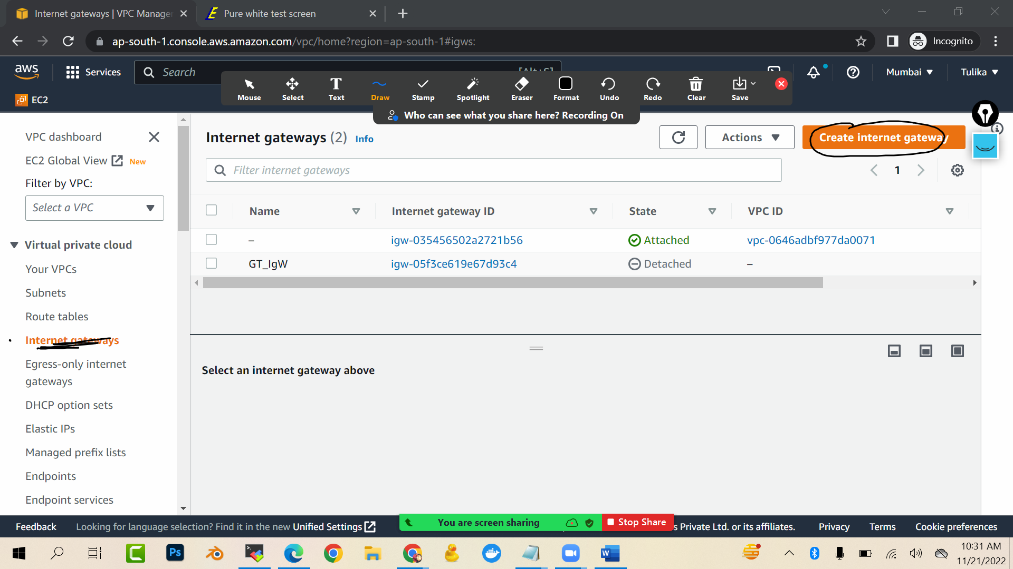

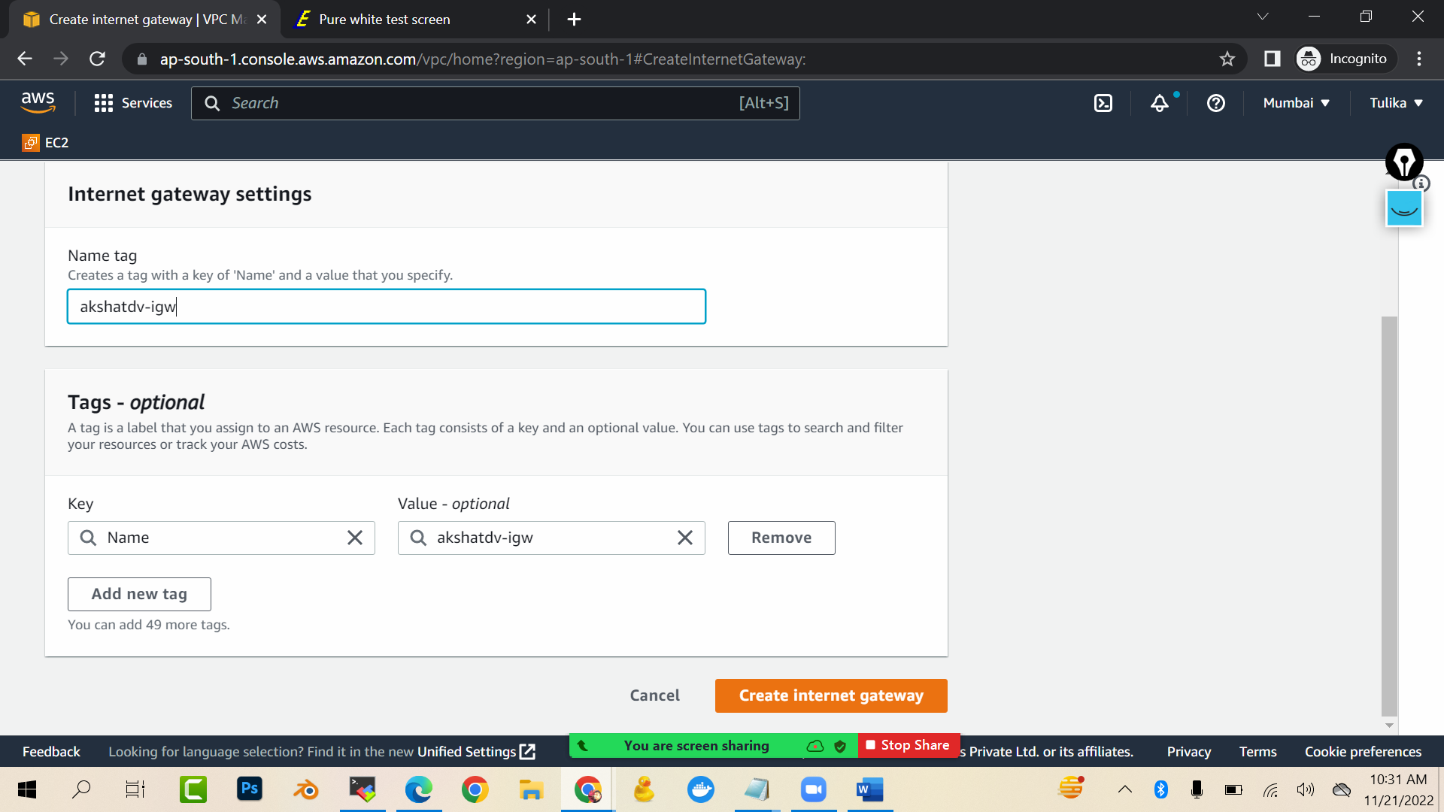

Create internet gateway

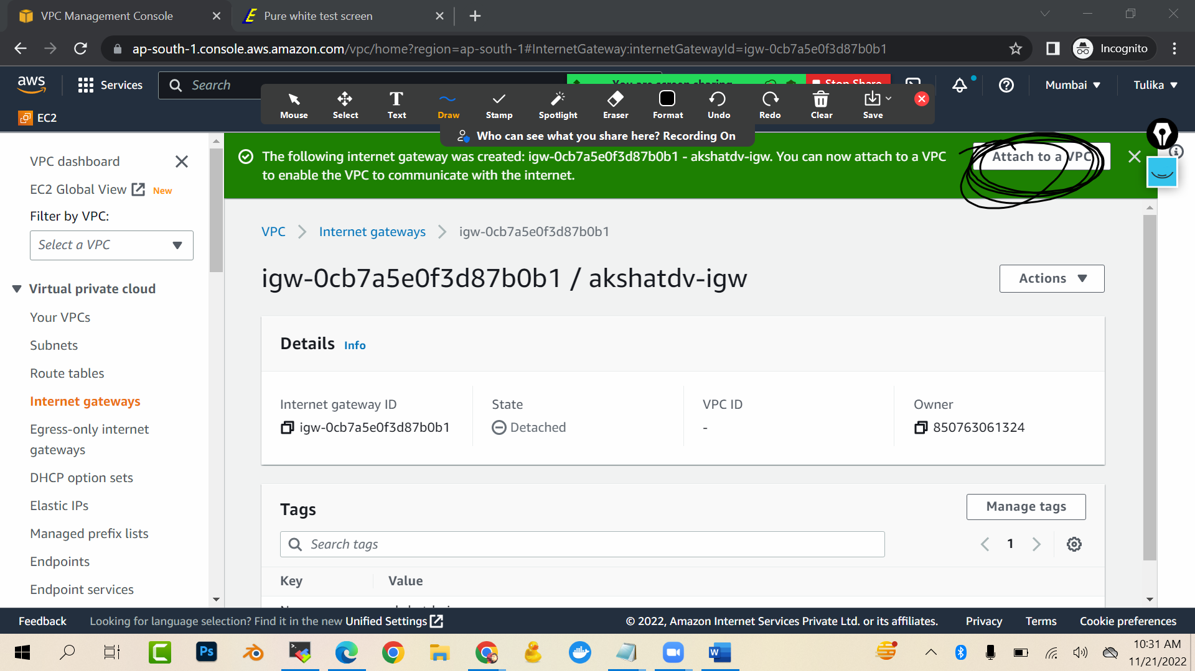attach it to the custom vpc u created

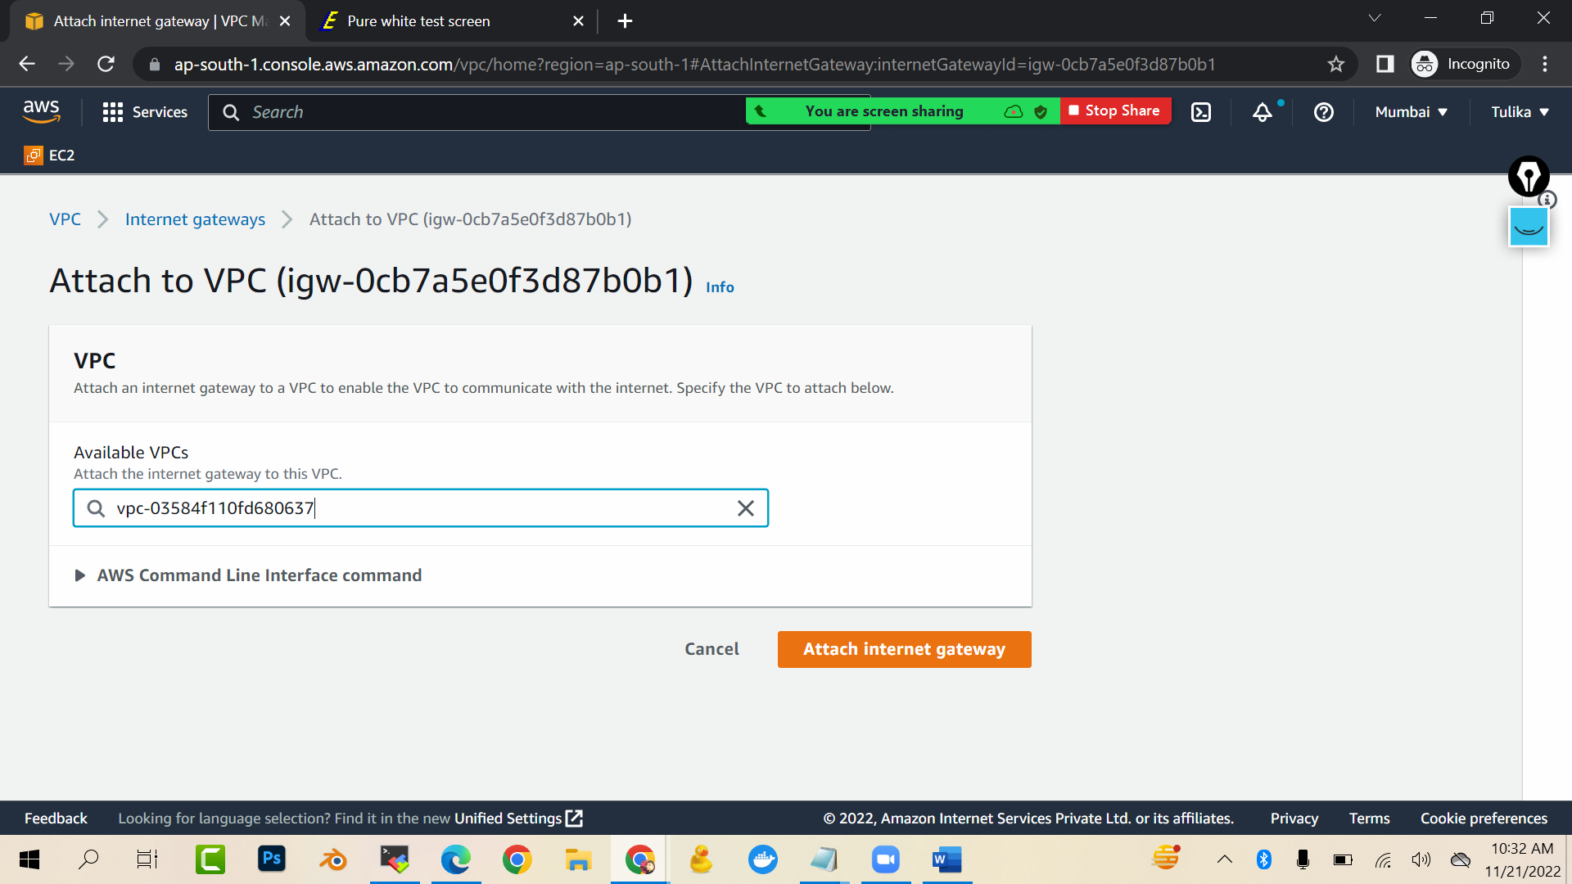

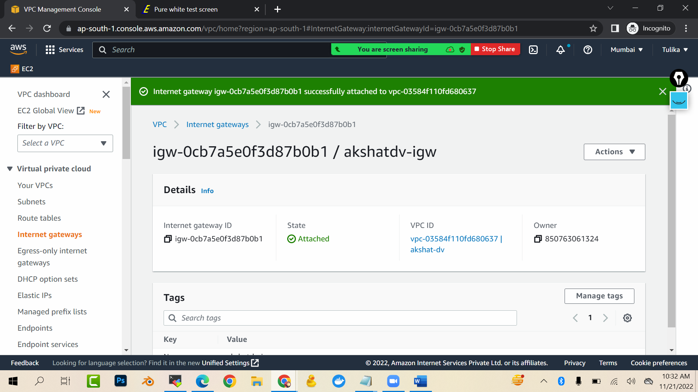

Now we will create route tables …we will create 2 route tables in which we will give path of one route table to internet and we will give not give path of other route table

To internet and then we will associate them with subnet1 and subnet2. Now the subnet with which to connected to route table with internet gateway is public subnet and otherone will be known as private subnet

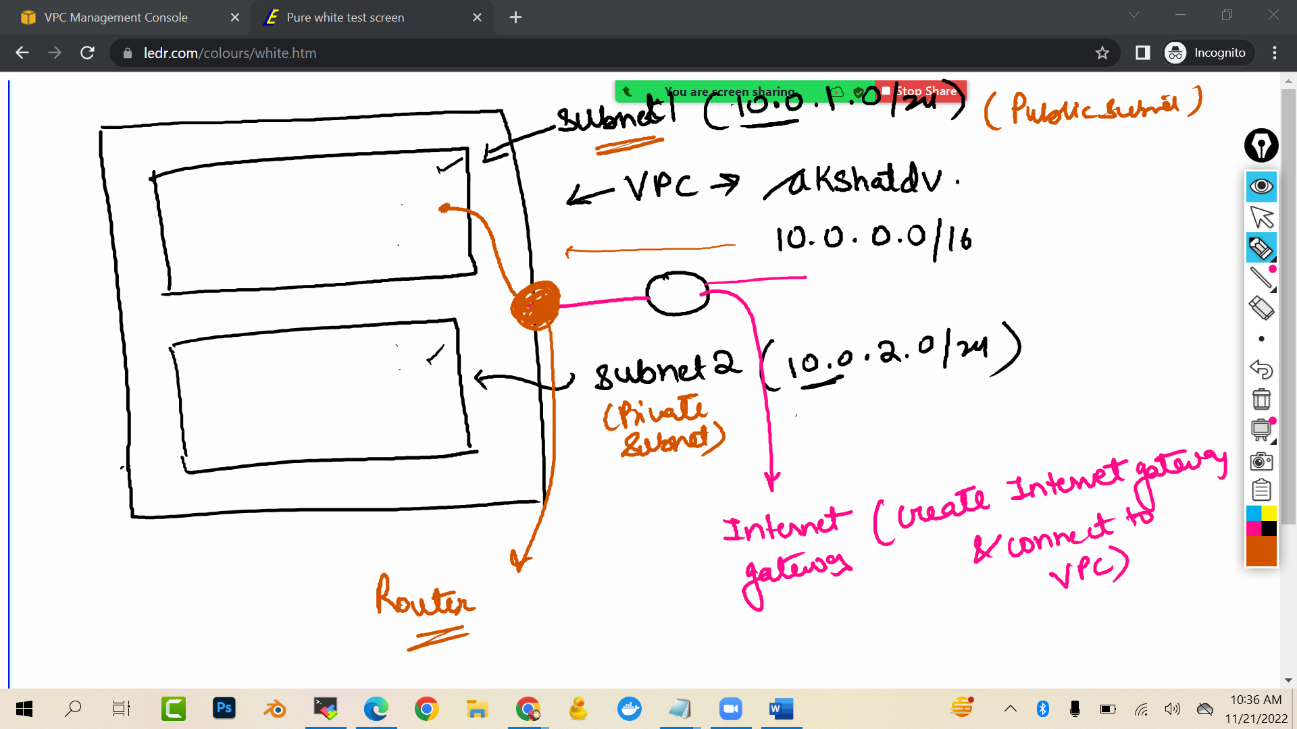

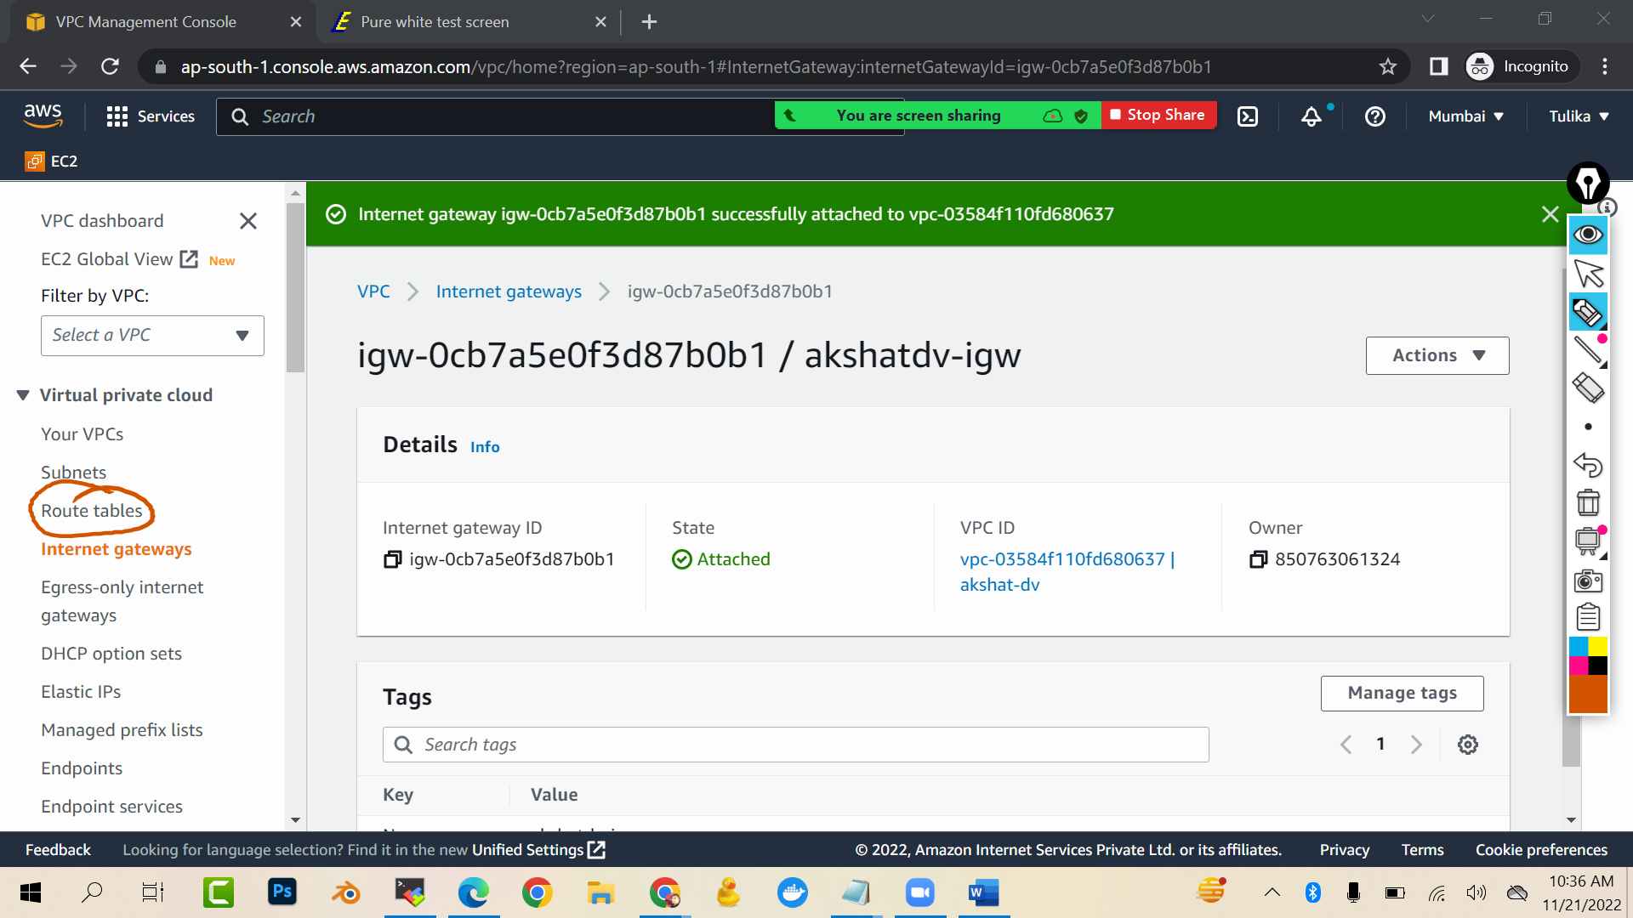

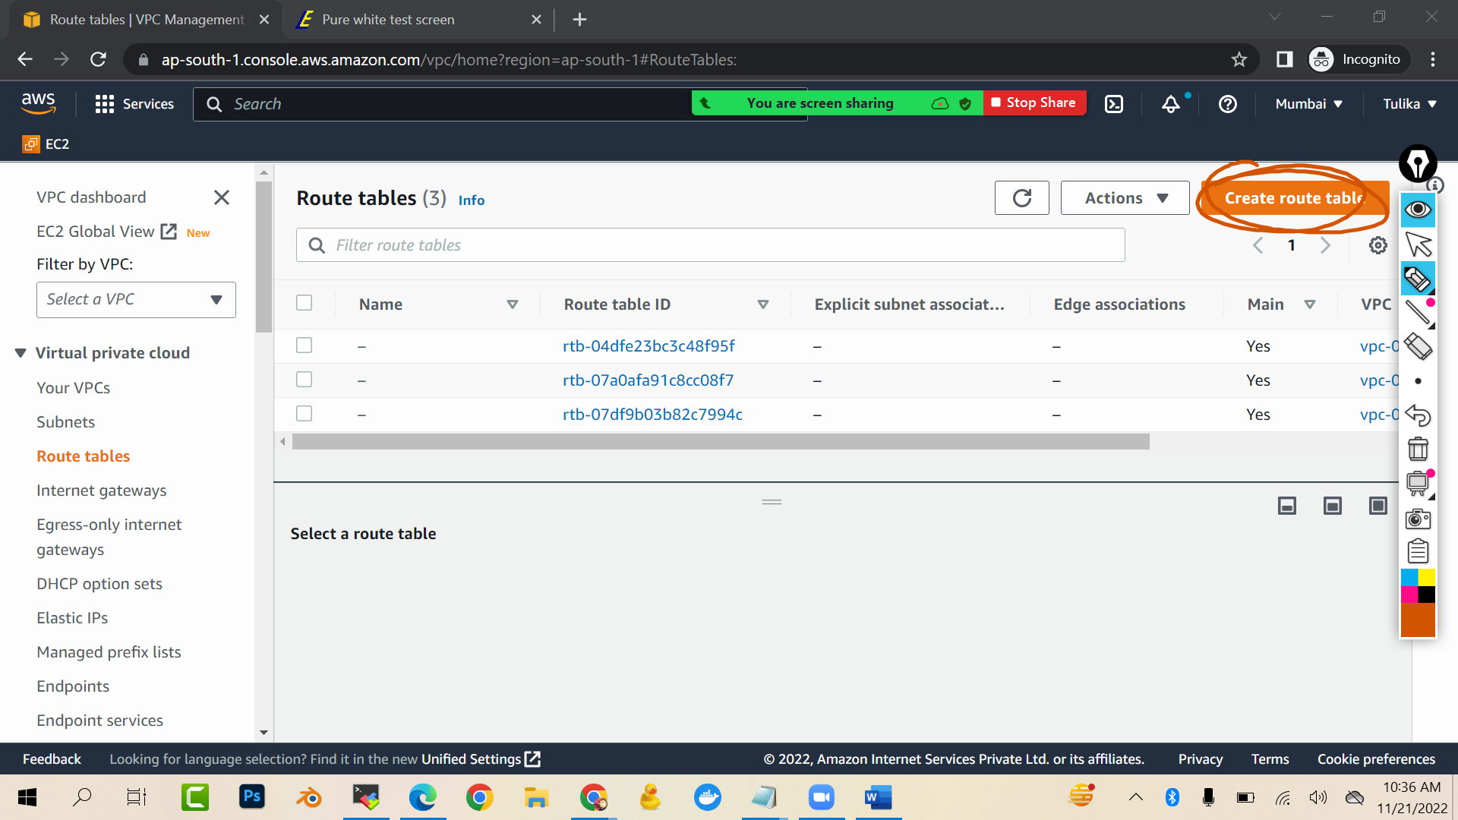

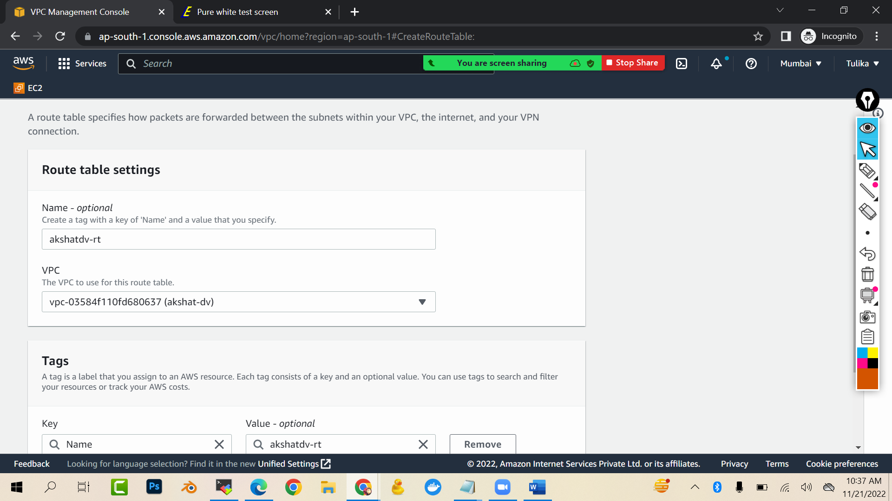

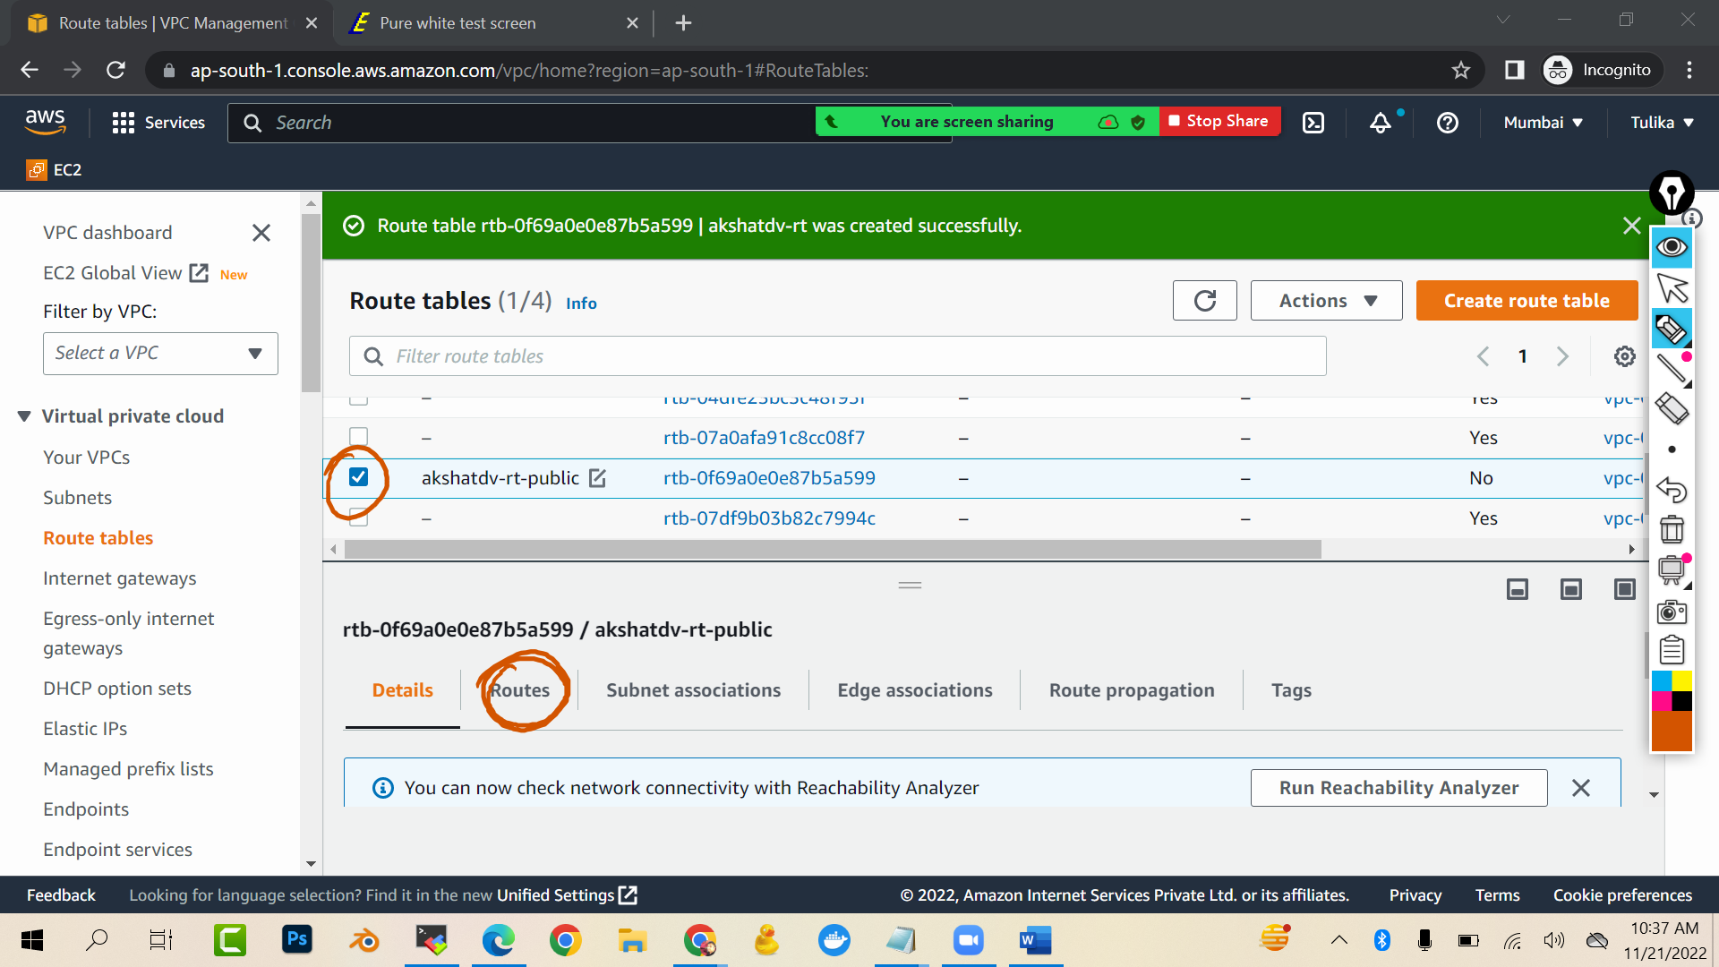

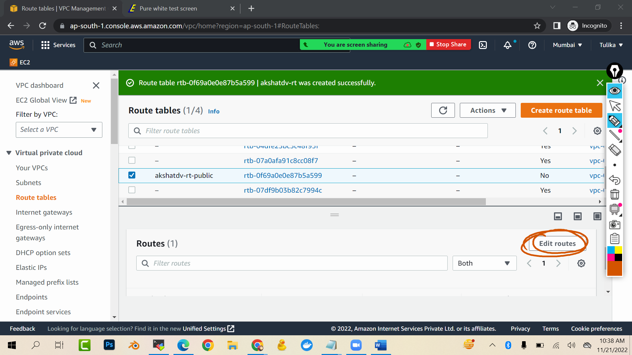

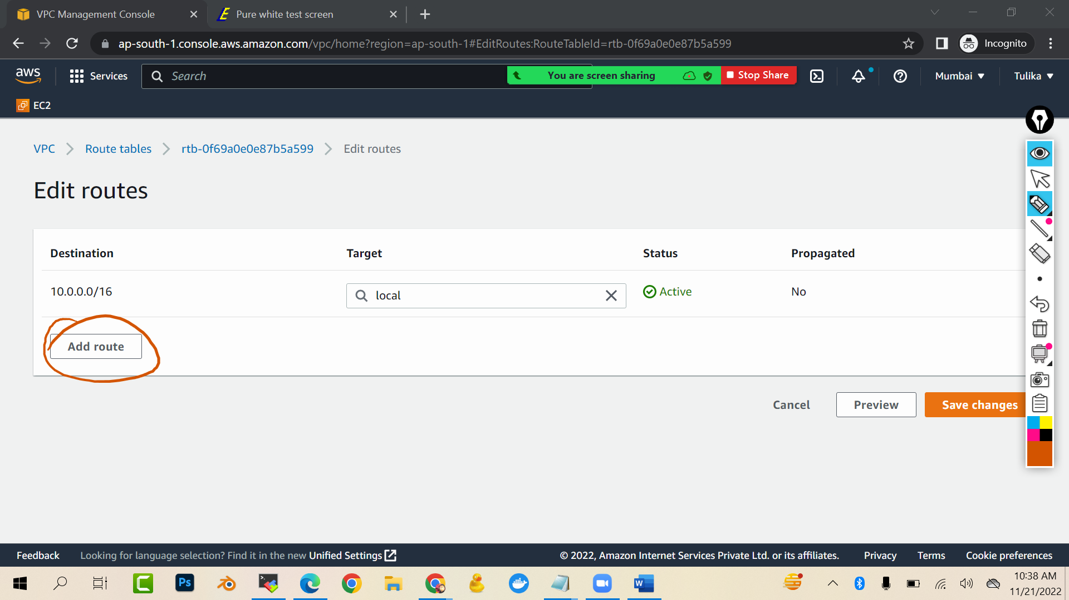

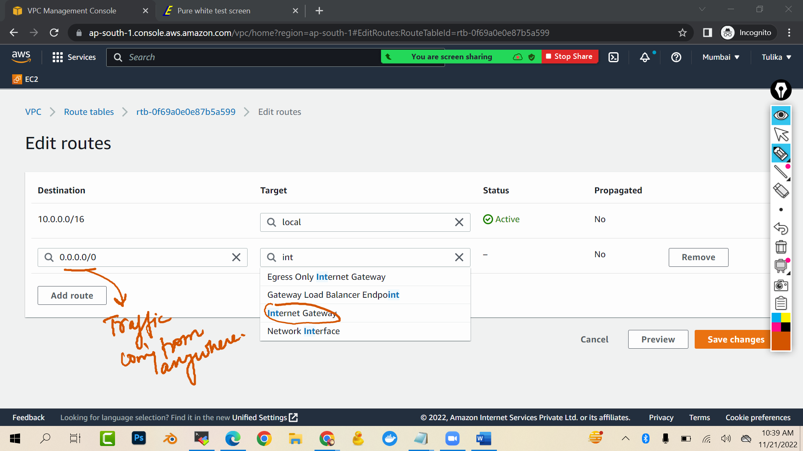

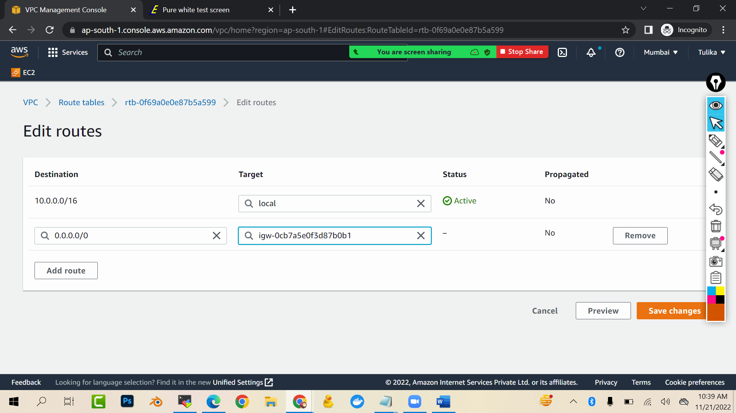

Save …now we have to associate this route table with a subnet

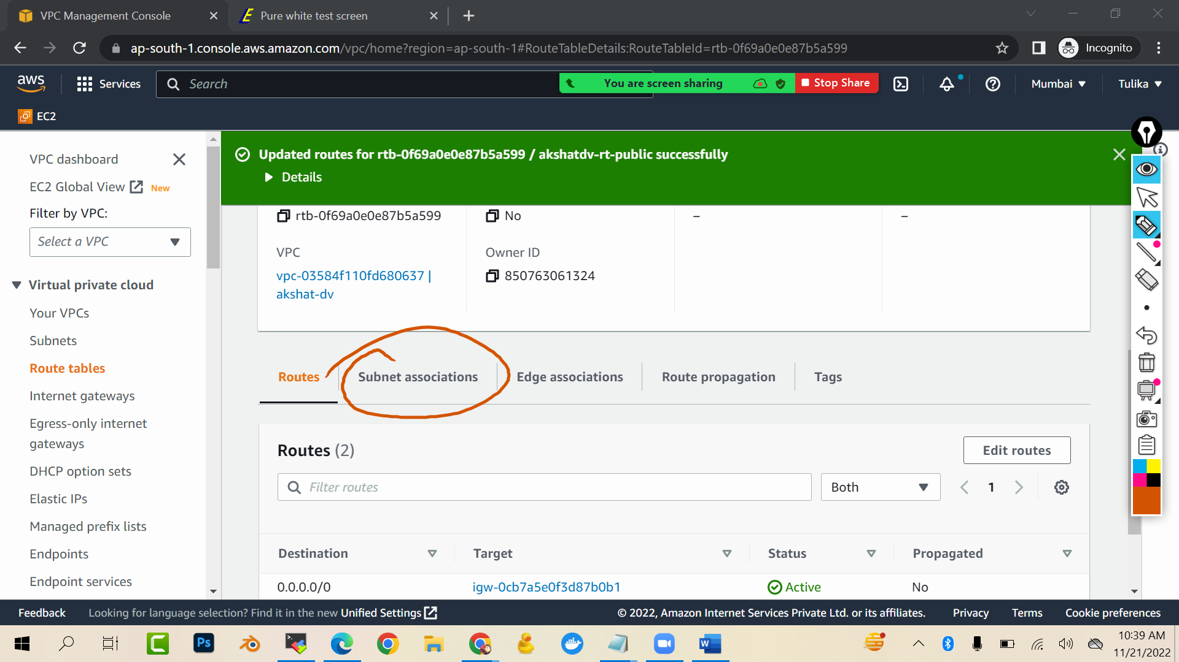

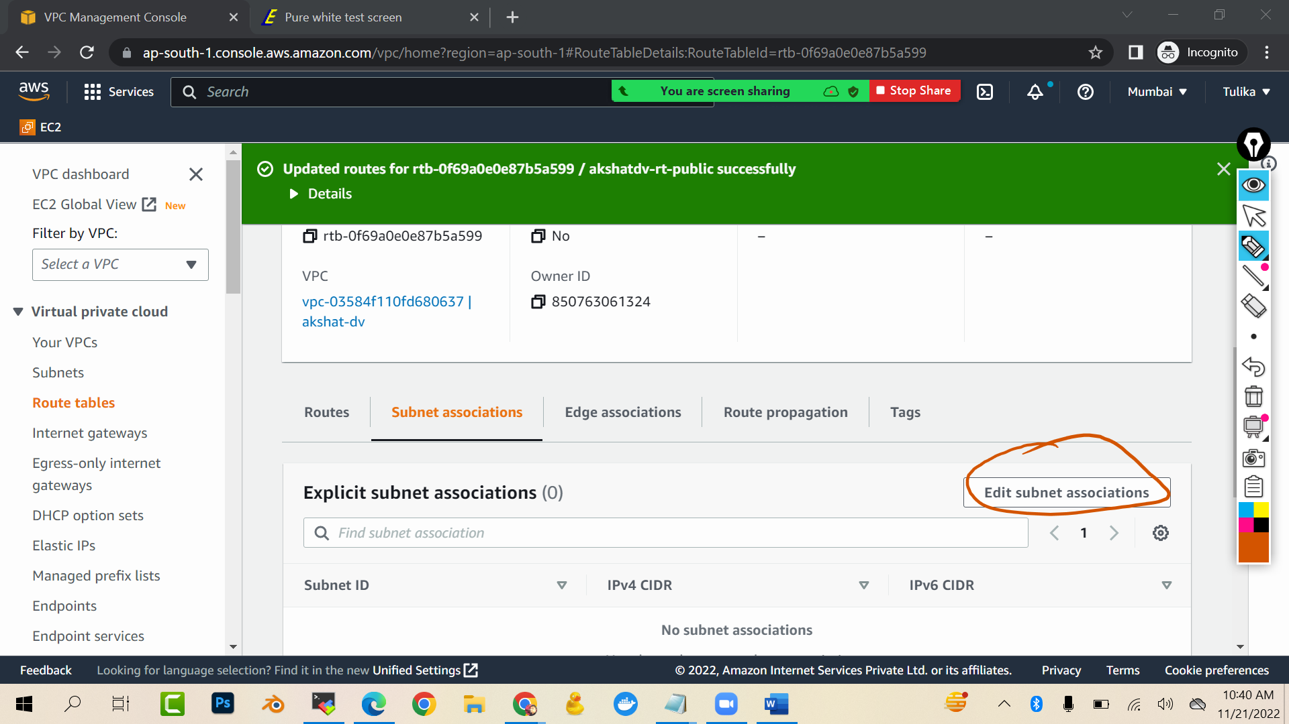

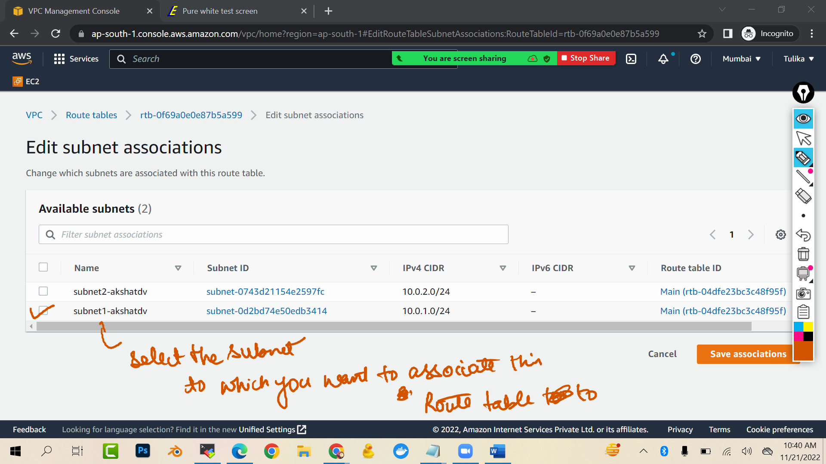

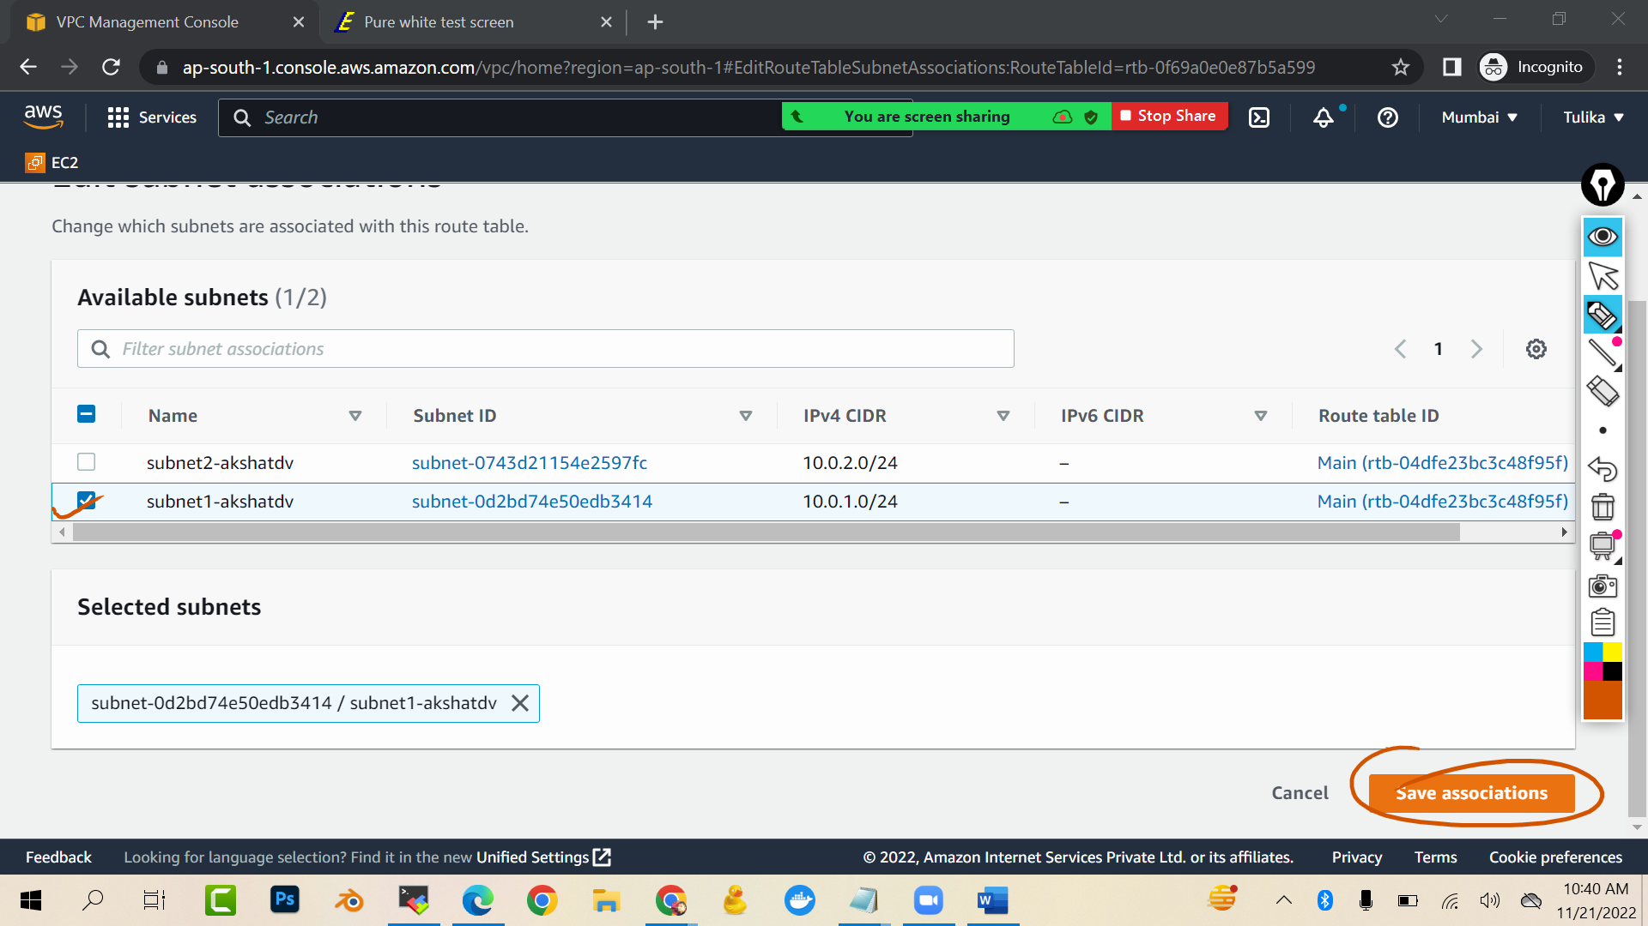

Now lets create private route table

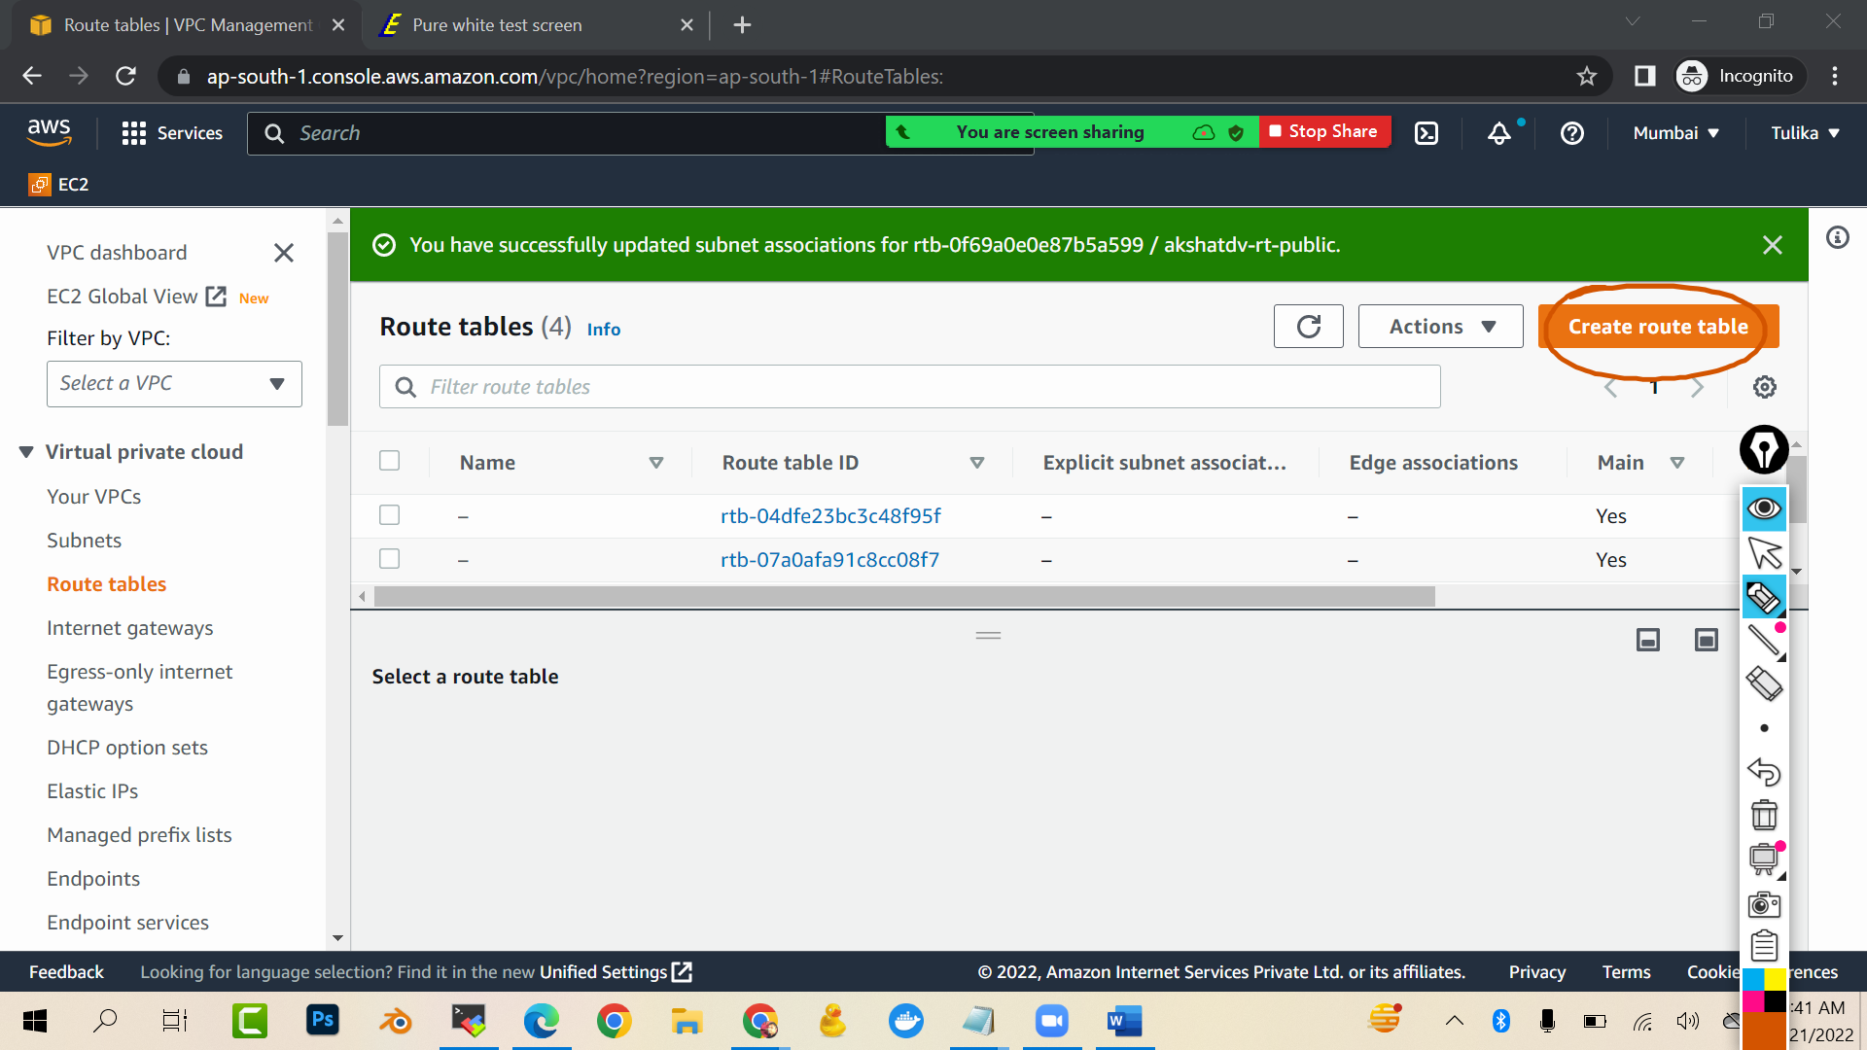

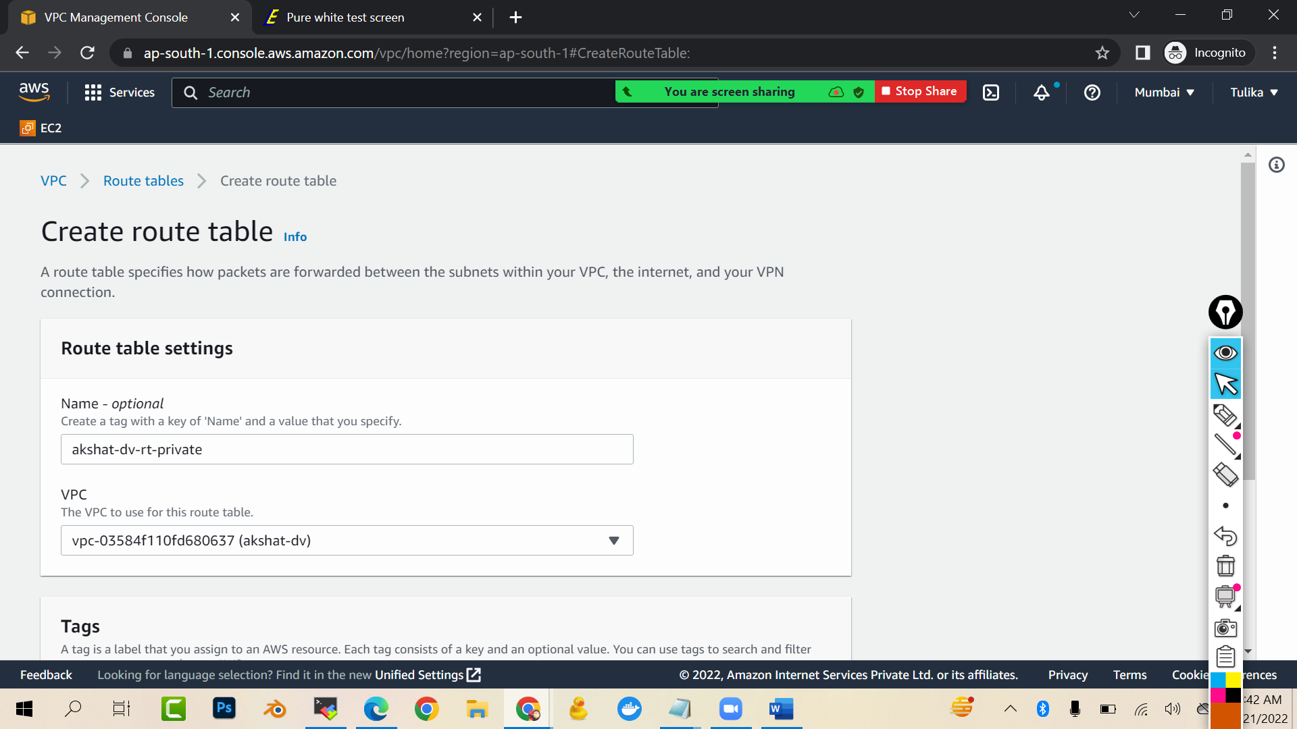

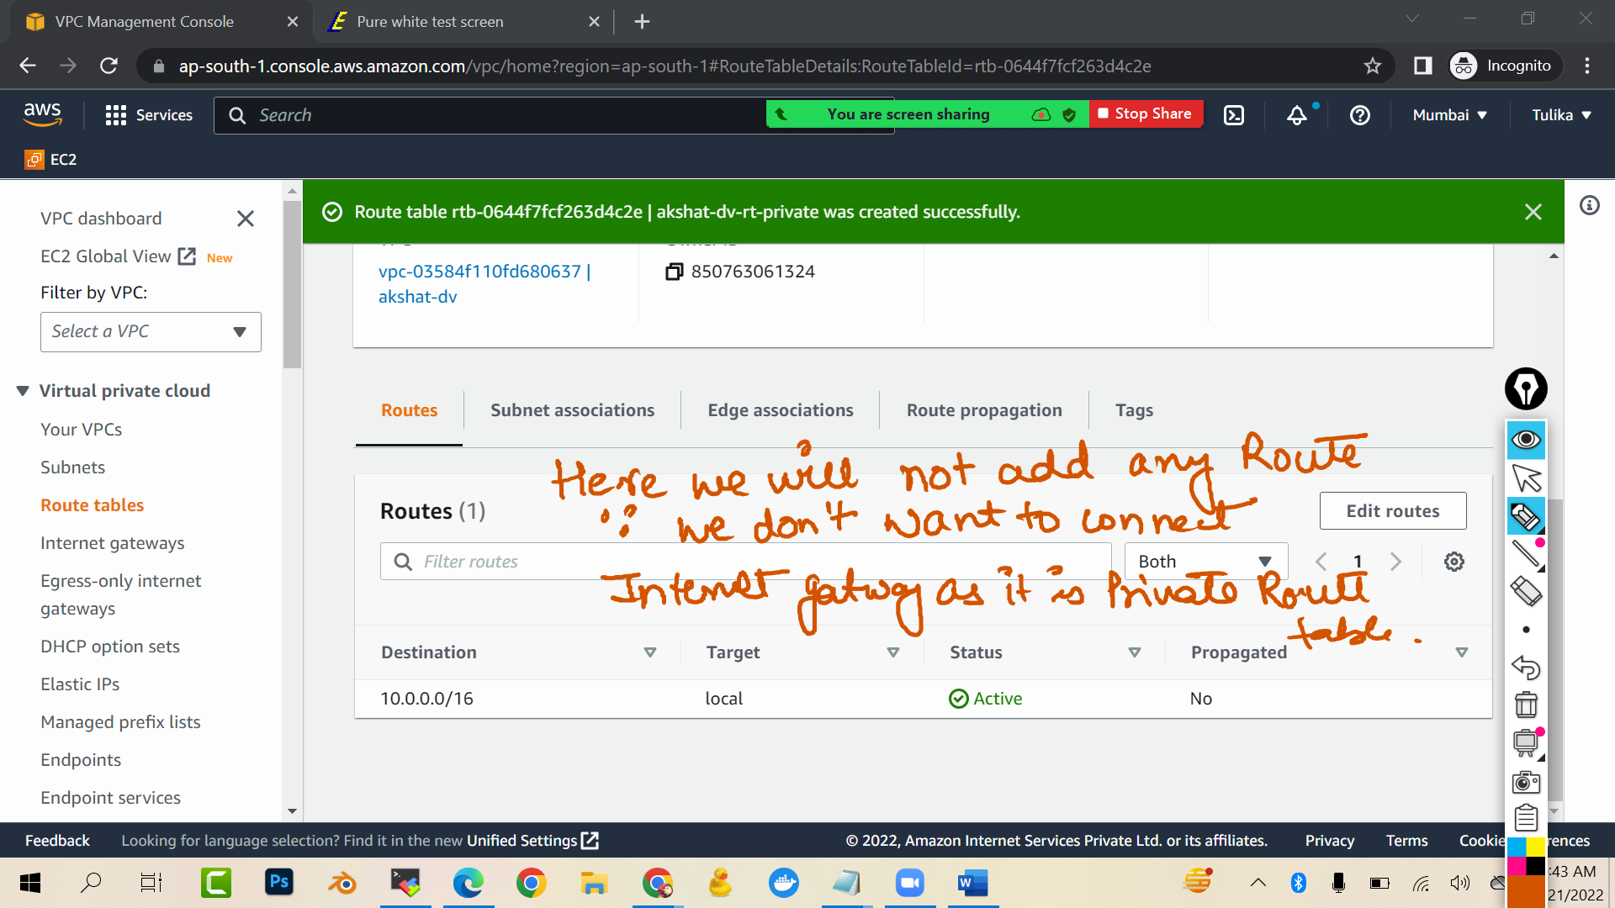

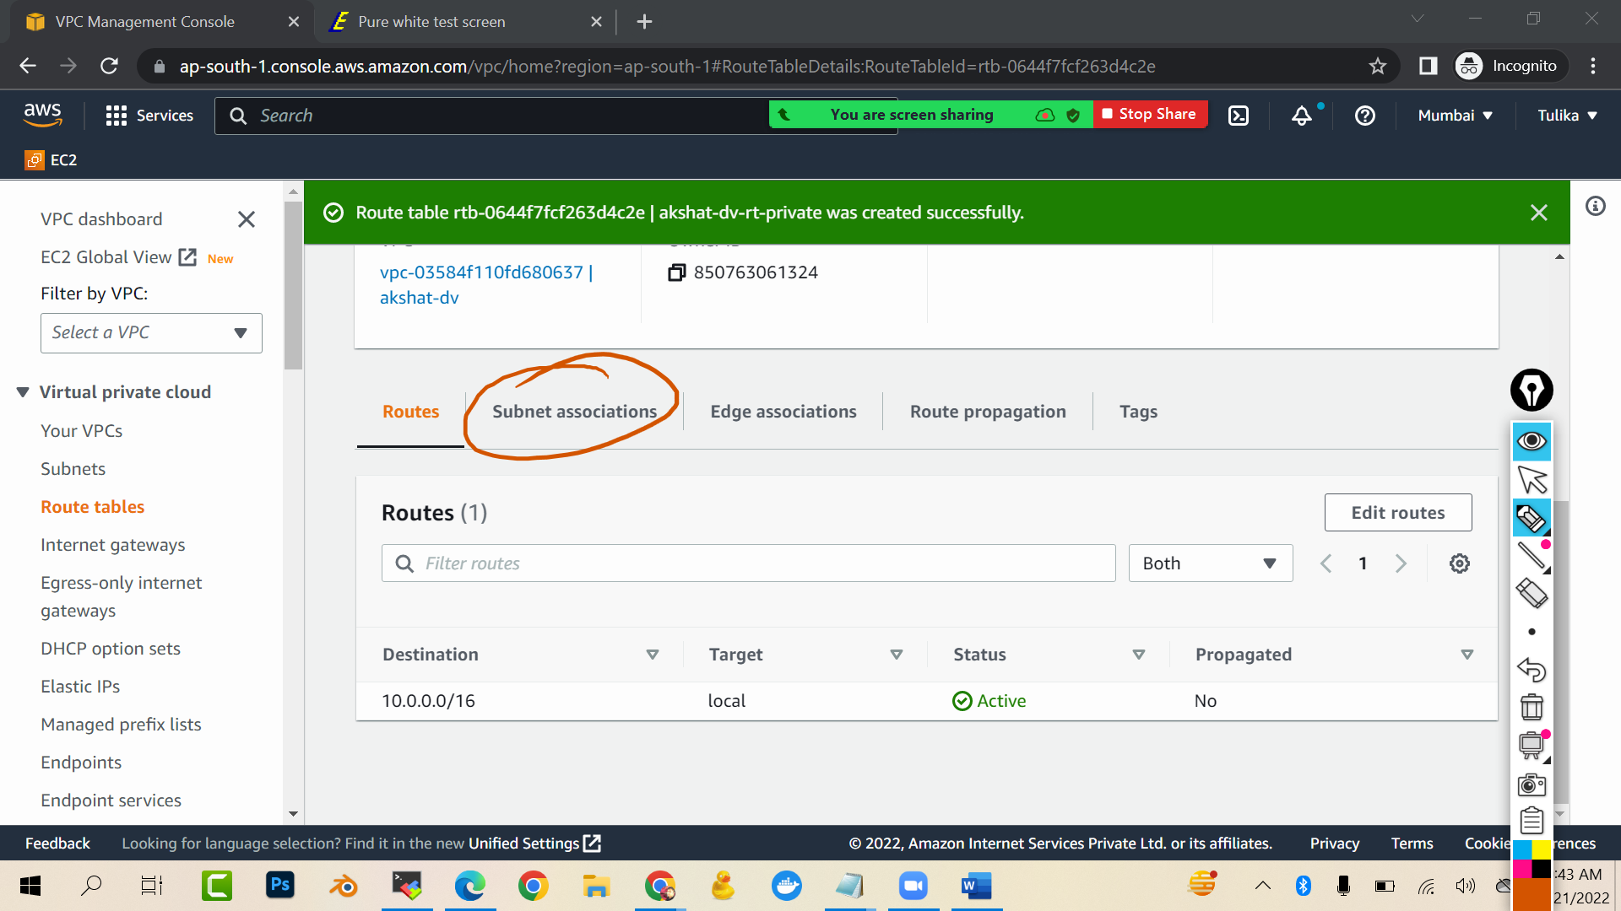

Edit subnet association

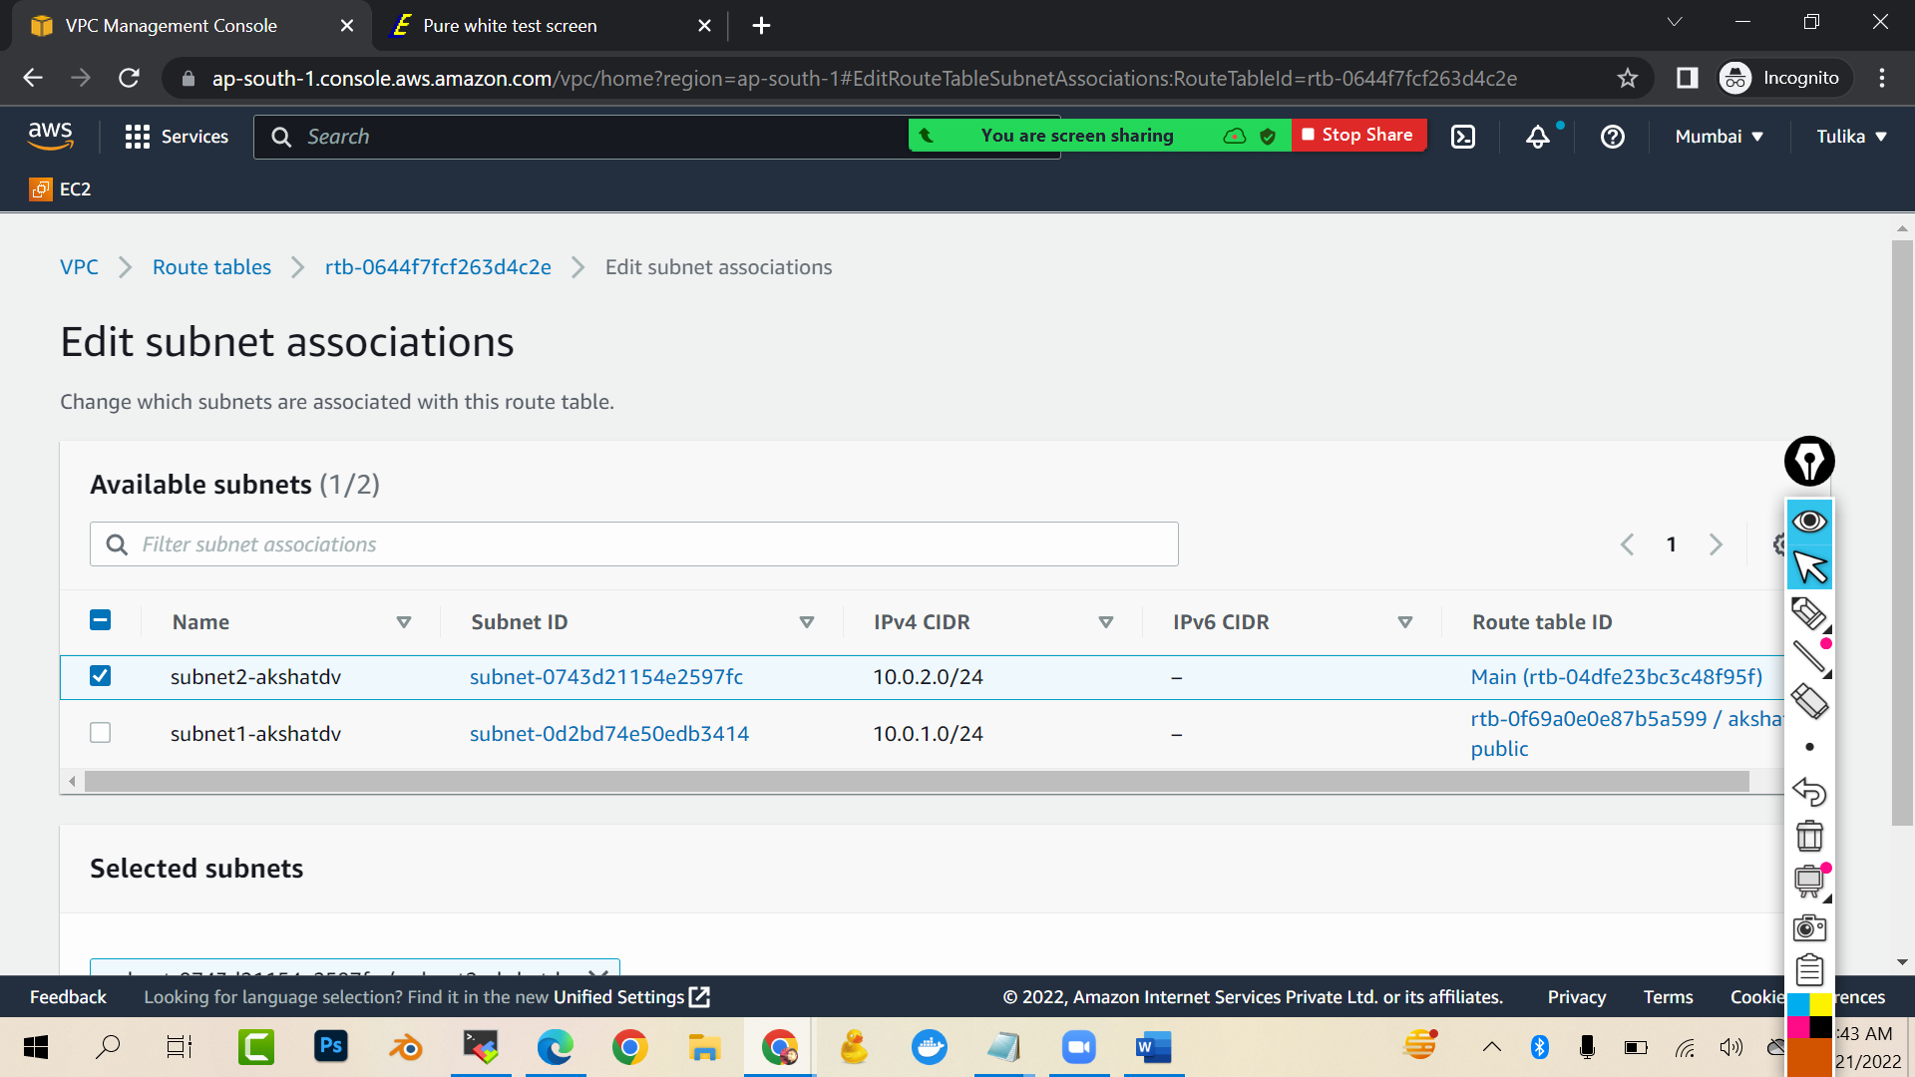

Save association

..

Now we will create public and private ec2 machine…public machine we will create in public subnet (subnet1) and private machine we will create in private subnet

Simply launch a linux machine…

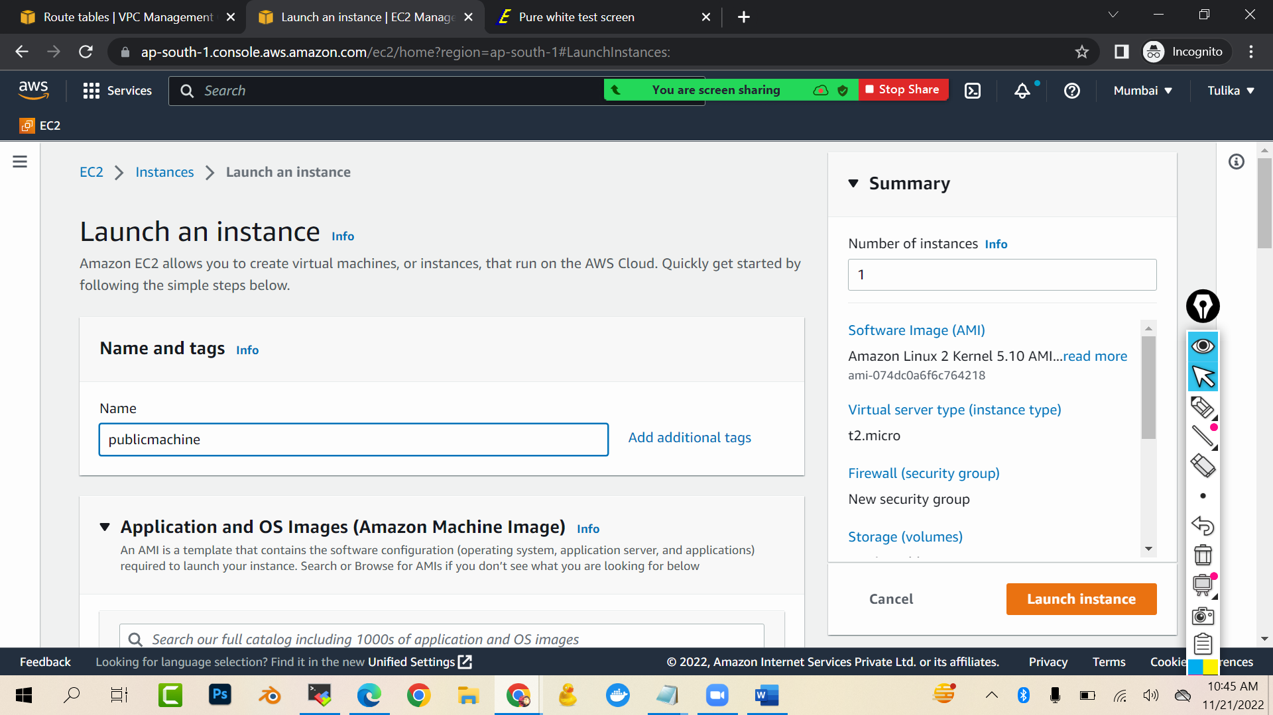

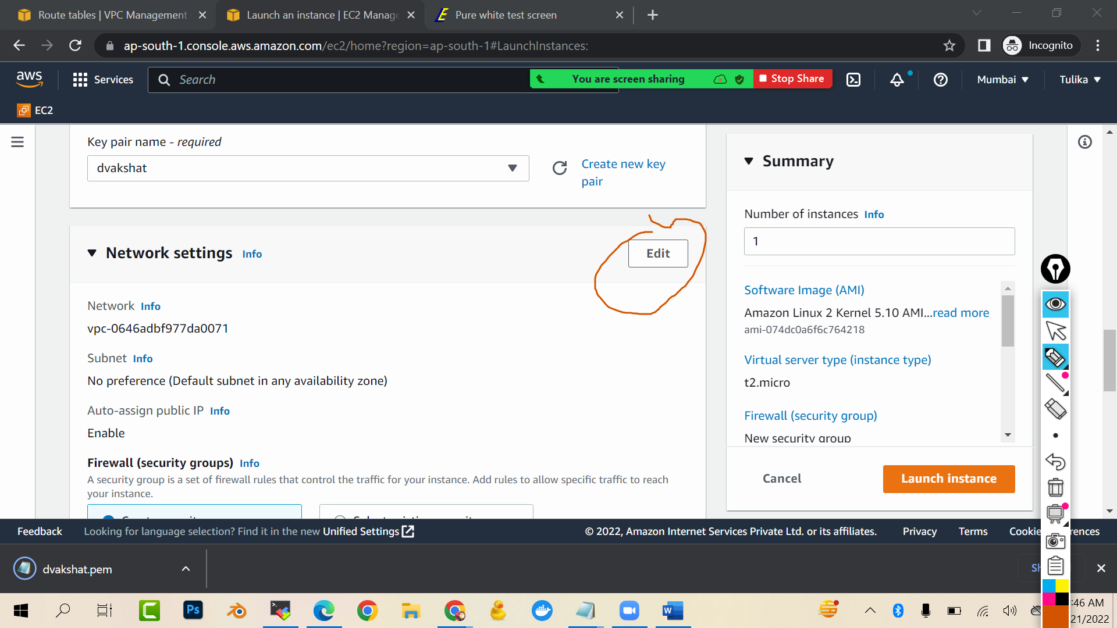

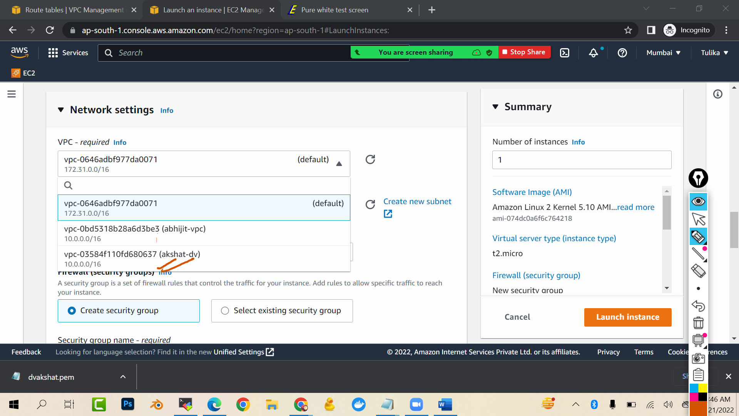

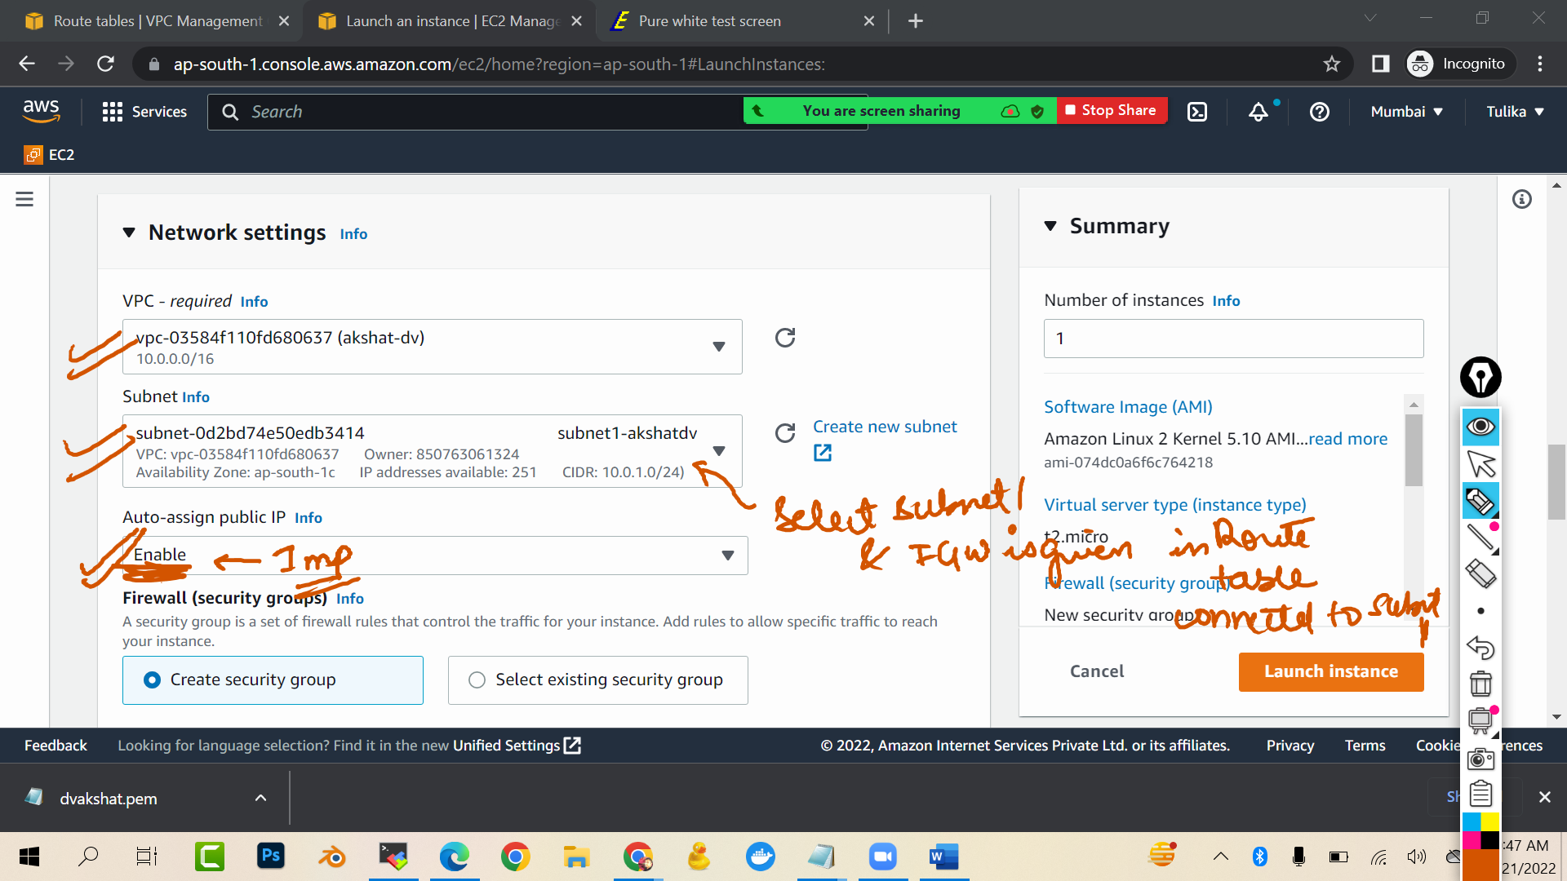

Launch machine

Launch public machine:

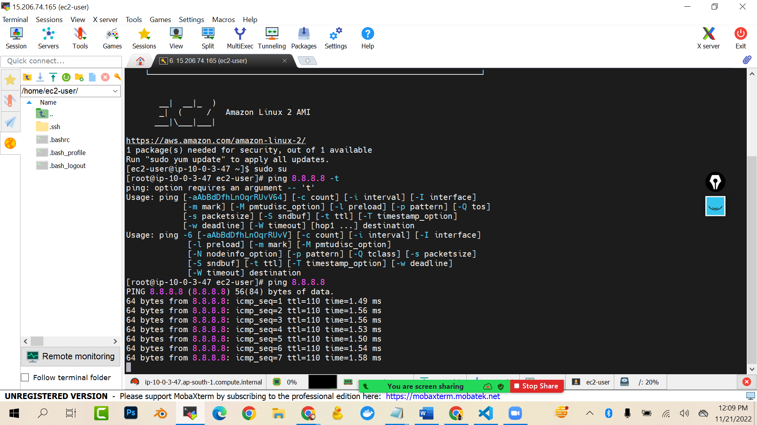

sudo su

ping 8.8.8.8 (you will get response)

Try connecting private machine…you will not be able to connected…because we are connecting from different network from internet that’s the reason.

Now we will connect the private machine from public machine

Go inside public machine

vi abc.pem (assuming abc.pem is the keypair which you created while creating private machine)

press i to start inserting

and paste the keypair content of the private machine

to exit press escape :wq

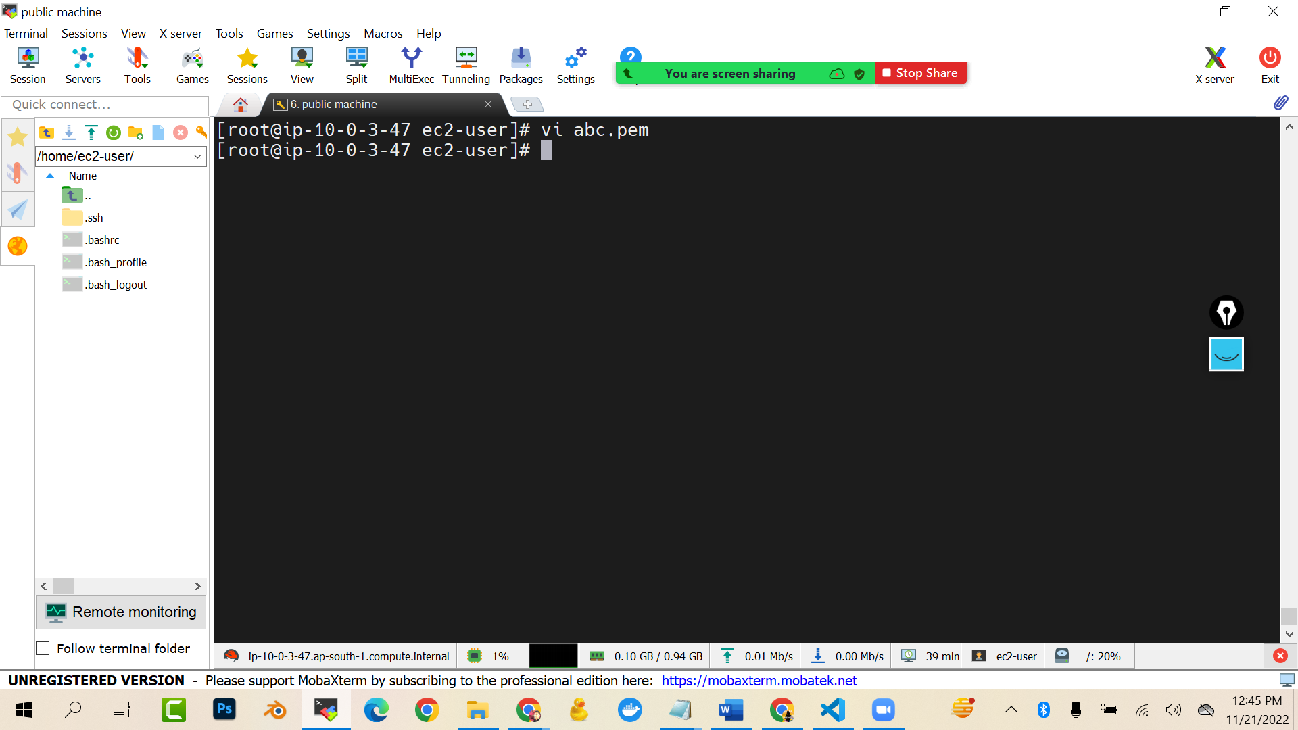

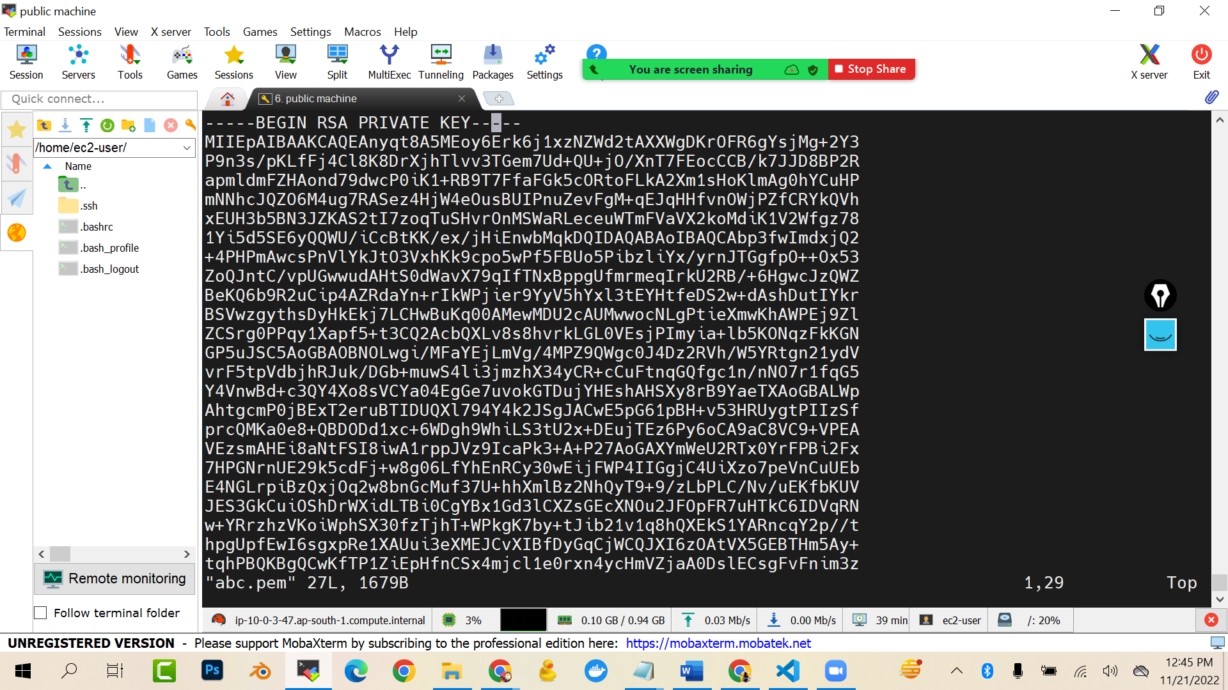

chmod 700 abc.pem (change the file permissions)

ssh -i abc.pem [ec2-user@10.0.5.59](mailto:ec2-user@10.0.5.59)

(here 10.0.05.59 Is the private ip of your private machine..replace this ip with you ip)

ping 8.8.8.8 (you will get timeout error because the private machine is not connected to internet)

### WE WILL HOW WE CAN INTERNET CONNECTIVITY TO PRIVATE MACHINE WITHOUT USING INTERNET GATEWAY

WE WILL USE NATGATEWAY

Go to vpc

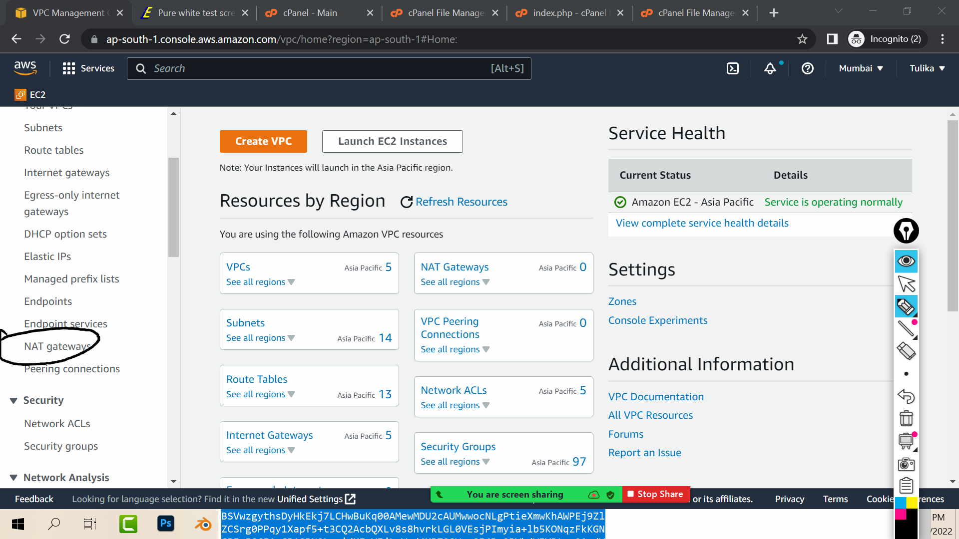

Create nat gateway

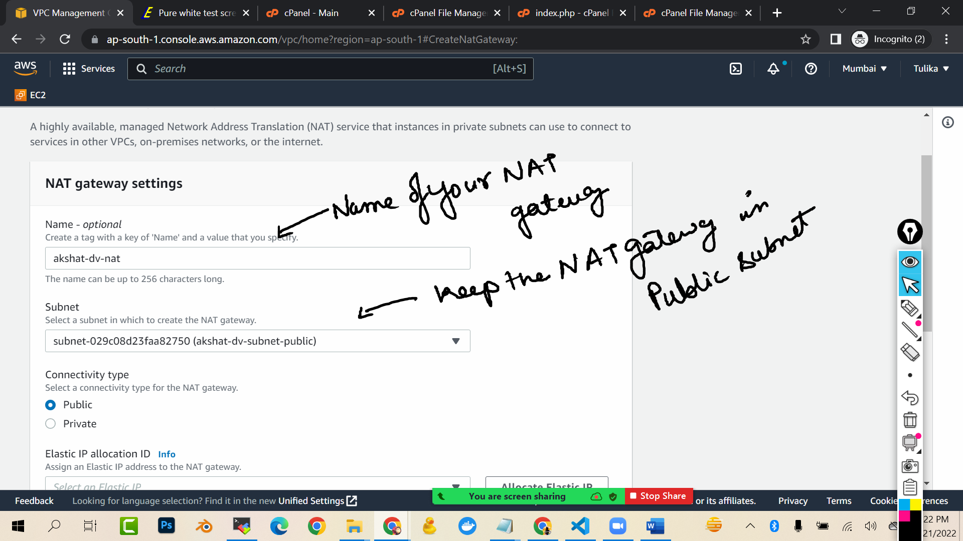

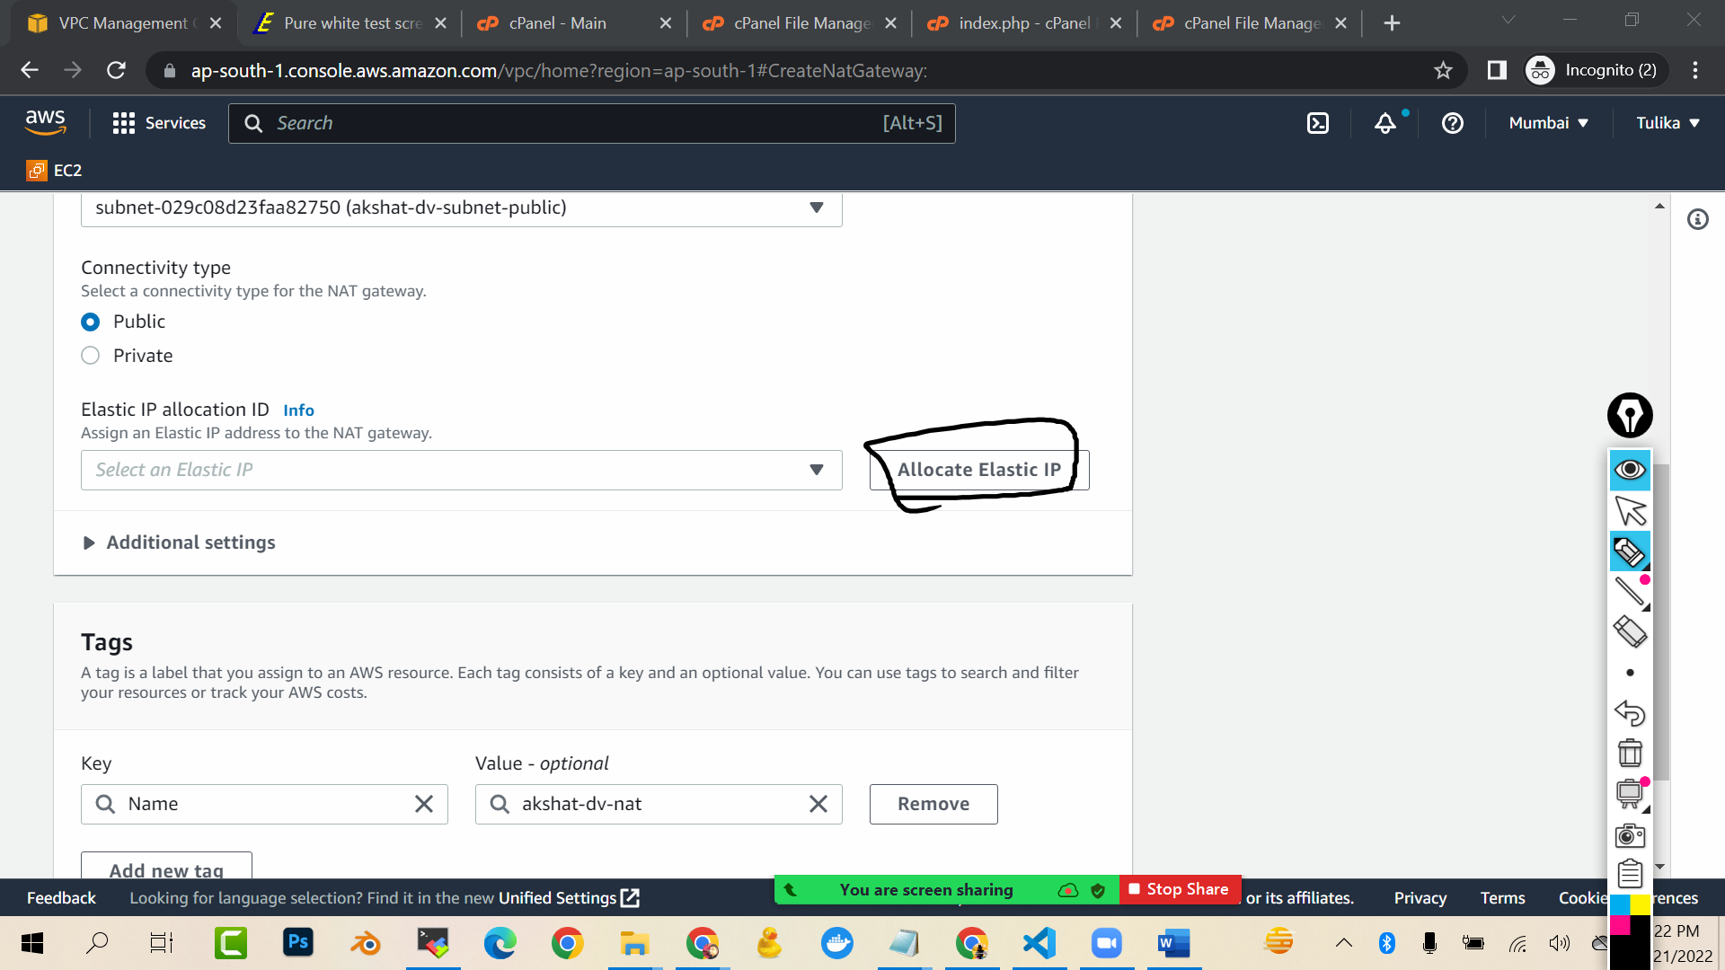

Create a nat gateway

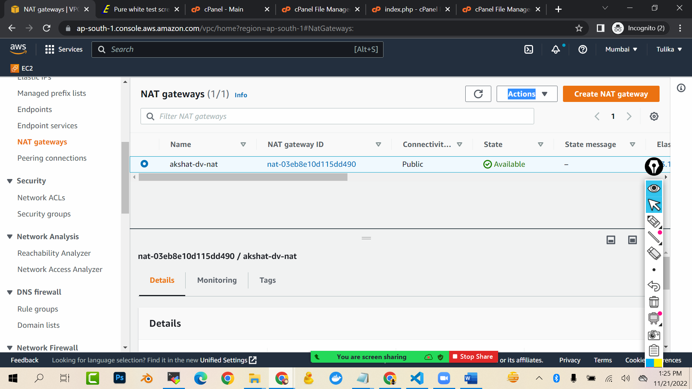

Now go to private route table and add path of your nat gateway

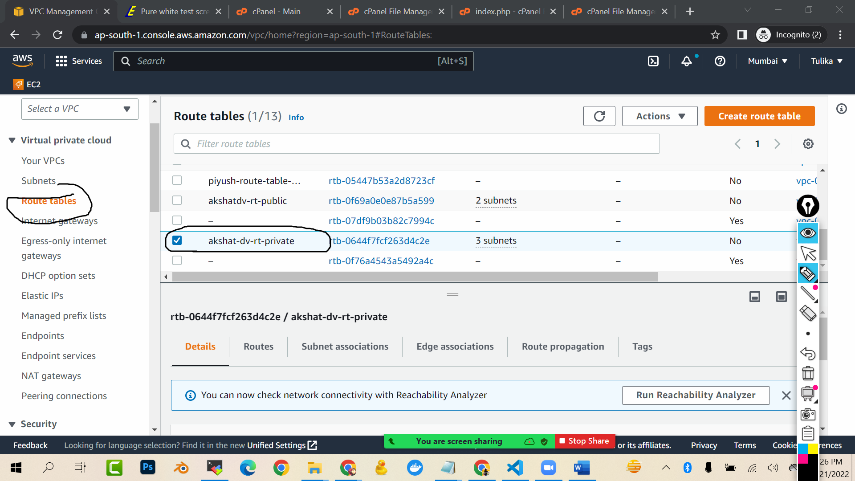

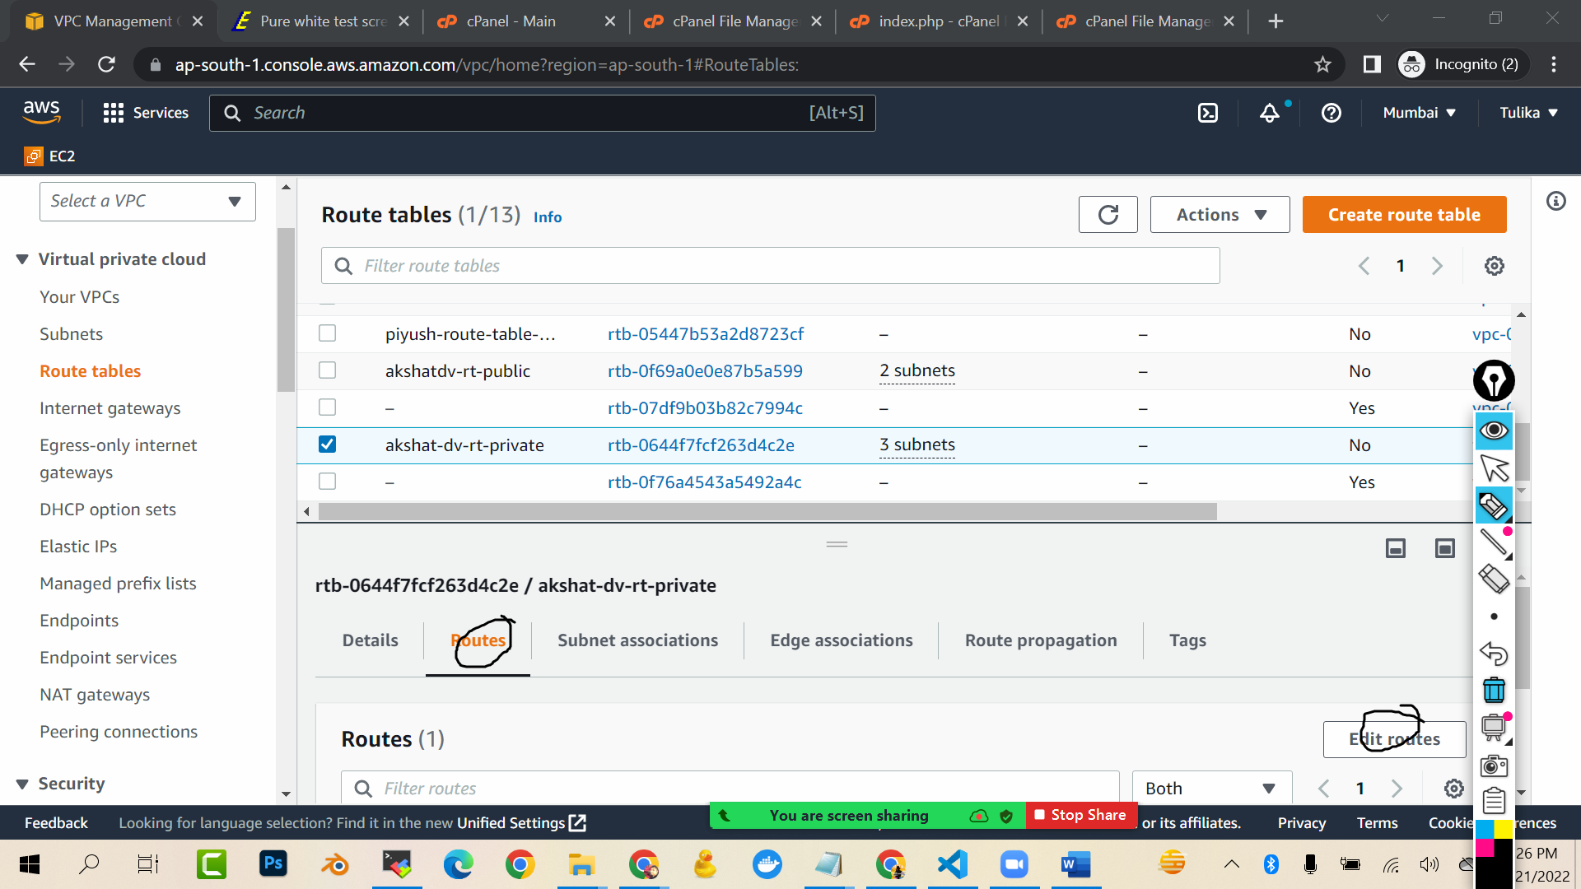

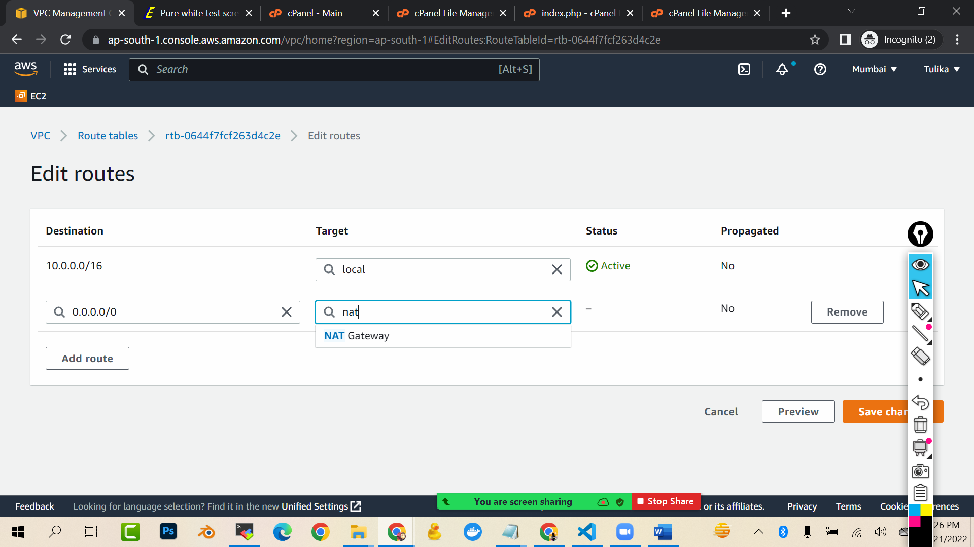

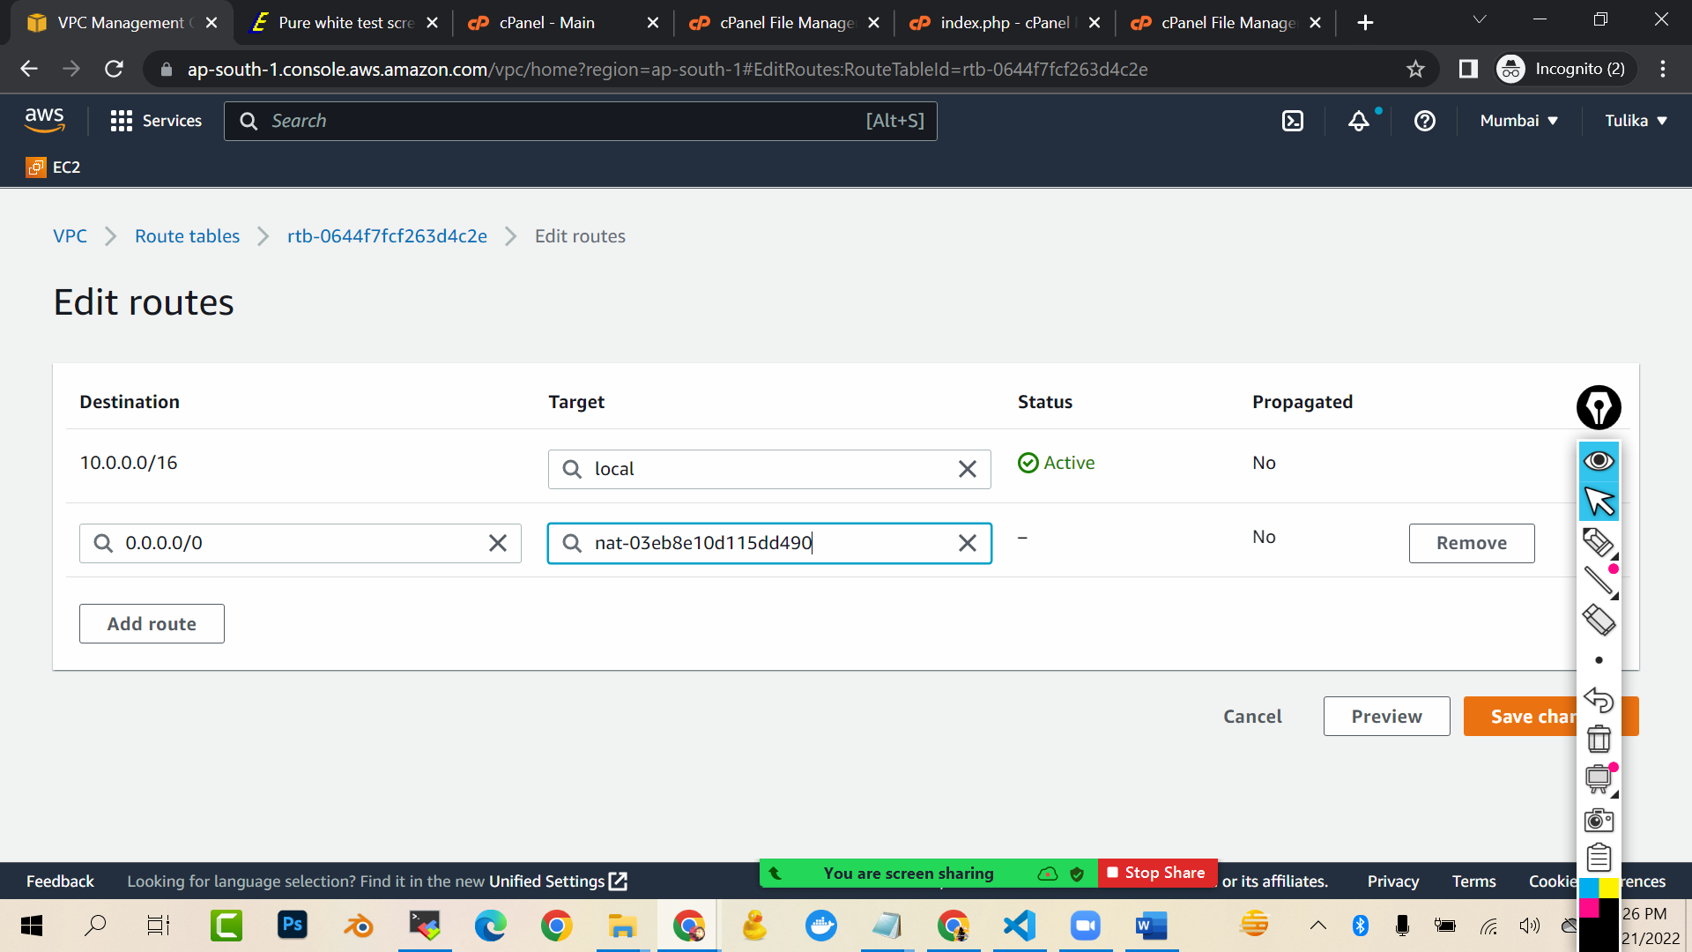

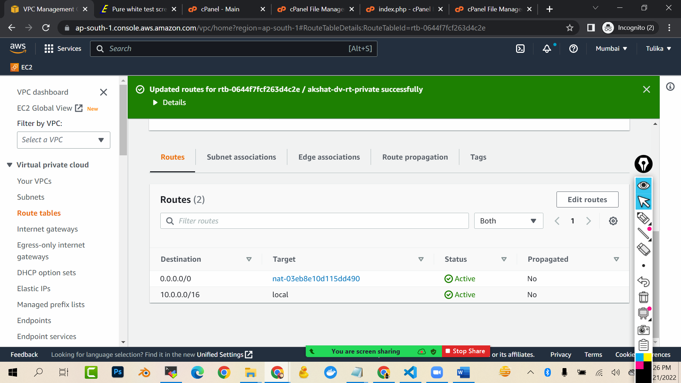

Now again to machine…and check now if you are able to ping 8.8.8.8 from private machine

